PatientFirst Admin Set-Up Manual

Table of Contents
Control File……………………………………………………………………………………………………………………………………………..3
Hospital Sites……………………………………………………………………………………………………………………………………….…3
Default Values..……………………………………………………………………………………………………………………………………….5
Interface Options…………………………………………………………………………………………………………………………………….8
Enable/Disable Features………………………………………………………………………………………………………………………….9
Age Limits, Targets and Categories. ……………………………………………………………………………………………………..11
Registration Field Control..……………………………………………………………………………………………………………………12
Style Sheets…………………………………………………………………………………………………………………………………………..13
Advice Sheets. ………………………………………………………………………………………………………………………………………14
Alcohol Audit………………………………………………………………………………………………………………………………………...15
Site Transfer Details. …………………………………………………………………………………………………………………………….15
Smoking Audit..……………………………………………………………………………………………………………………………………..16
Assault Audit..……………………………………………………………………………………………………………………………………….16
Triage Assessment Options. …………………………………………………………………………………………………………………17
Interface Settings………………………………………………………………………………………………………………………………….19
PAS/PMI………………………………………………………………………………………………………………………………………………..19
Order Communications………………………………………………………………………………………………………………………...22
Message Board..……………………………………………………………………………………………………………………………………23
Document Management……………………………………………………………………………………………………………………….24
GP Letter Document Export………………………………………………………………………………………………………………….25
User Admin…………………………………………………………………………………………………………………………………………..27
Personnel Maintenance………………………………………………………………………………………………………………………..30
Printing Settings..………………………………………………………………………………………………………………………………….32
GP Admin……………………………………………………………………………………………………………………………………………...34
GP Maintenance……………………………………………………………………………………………………………………………………36
Document Print Setup…………………………………………………………………………………………………………………………..38
Version Control……………………………………………………………………………………………………………………………………..39
SQL Scripts…………………………………………………………………………………………………………………………………………...40

Control File

To start the setup process, load the main menu and click on Administration as below.
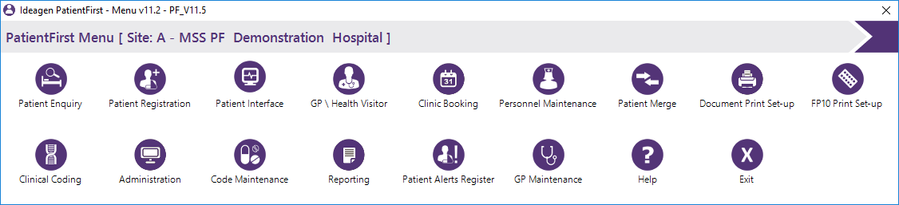

When the program is first loaded, you will need to select a hospital site from the list (if you have more than one site).

Hospital Sites

This screen simply allows you to edit information about the different hospital sites that are setup in the application. Double click a location to change the details, then click the update button when complete.

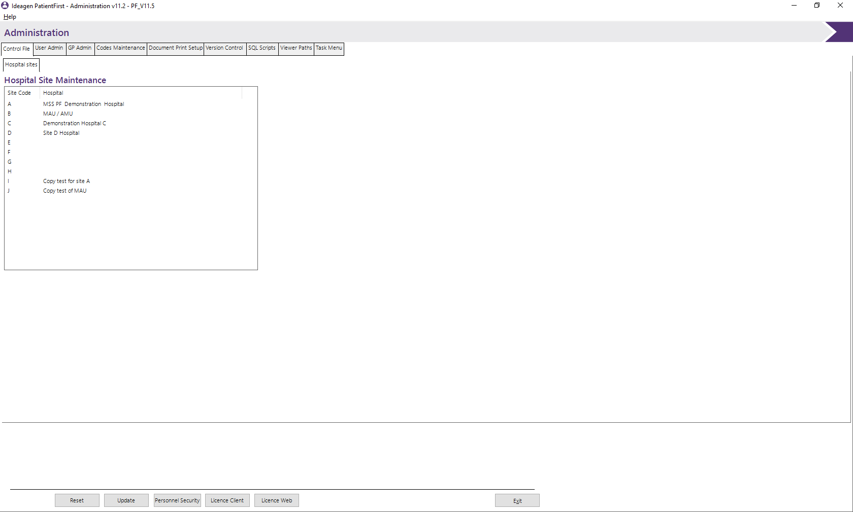

Hospital Details
The Hospital Details screen will then be displayed, probably containing information similar to that shown below because MSS ship a partially populated database. Replace the data with the correct hospital details and then click on update.
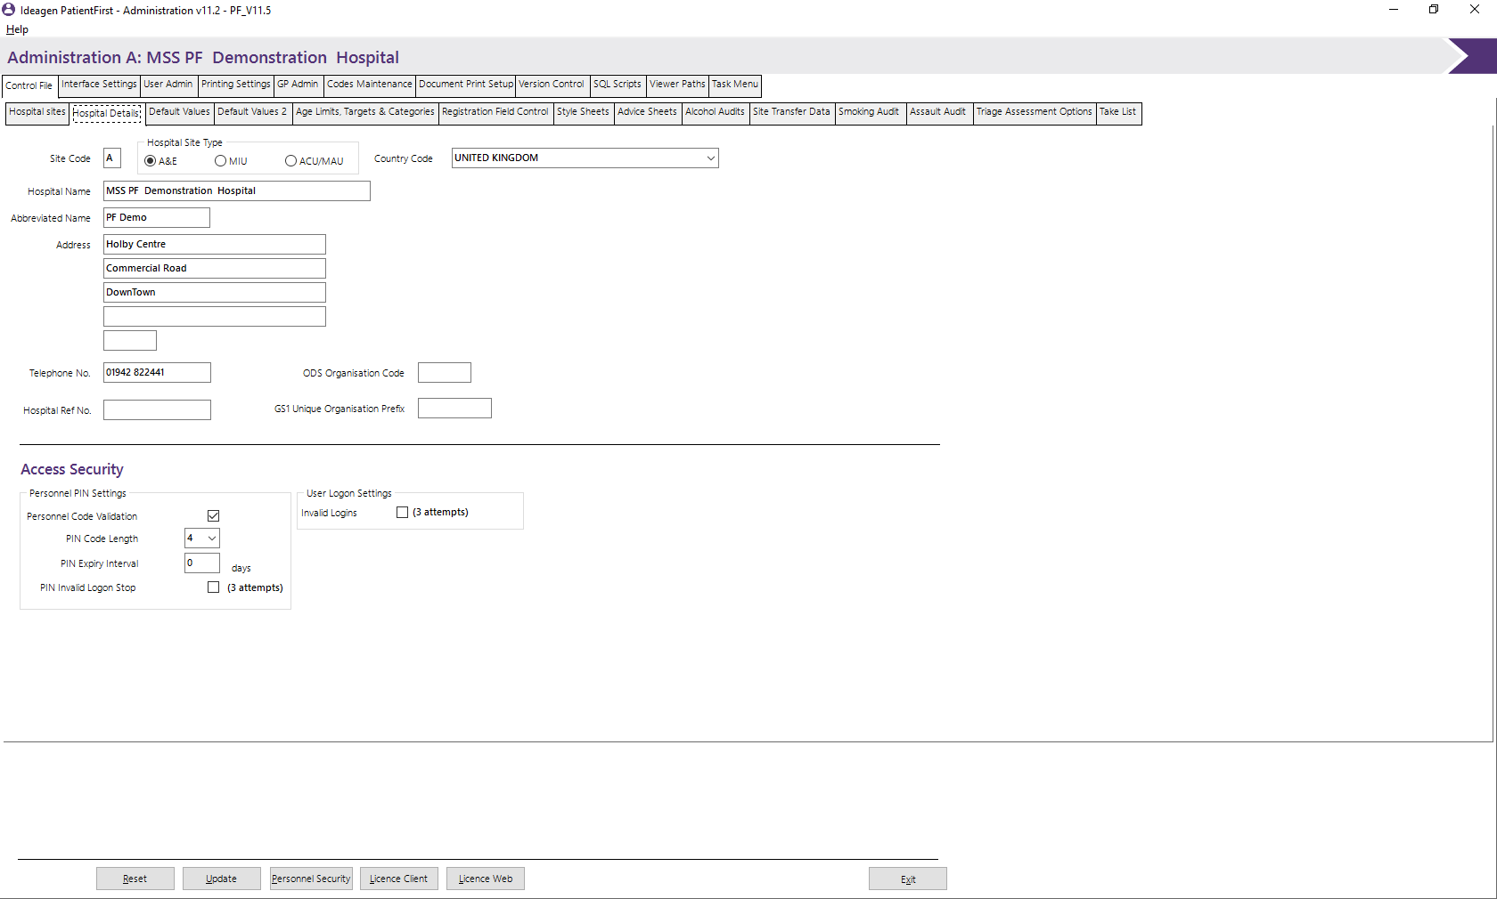

The ODS Organisation code and GS1 Unique Organisation Prefix refer to values for 2D barodes.

Access Security
These fields are used to determine the security Access values.

Personnel PIN Settings

Personnel Code Validation
Specifies whether personnel codes are to include a PIN number.

PIN code length
Select from the drop down list the required length of the PIN code, if personnel code validation is in use.

PIN Expiry Interval
Enter the PIN expiry value in days. This will force the change of the Personnel PIN number. Entering 0 or 999 will negate the need to change the PIN number.

PIN Invalid Logon Stop
Specifies that the logon function is disabled once the number of logon attempts has been exceeded.

User Logon Settings

Invalid Logins
This field is set to indicate that the logon attempts function is activated.

Default values

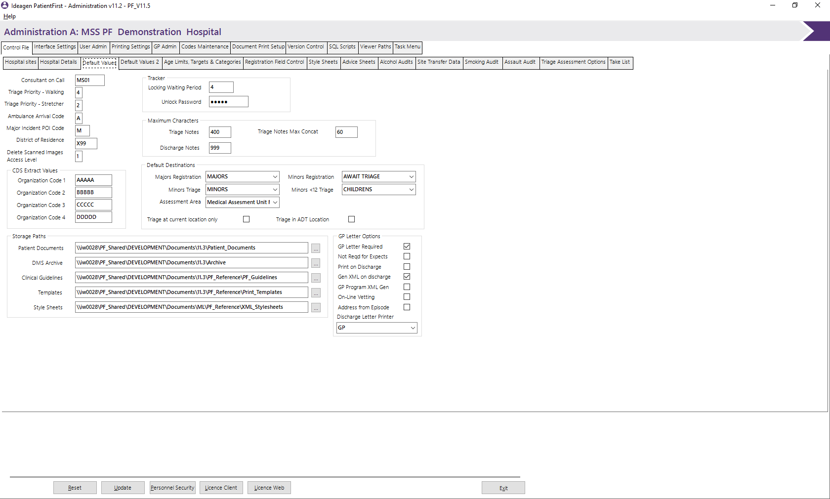
The Default Values screens enable the administrator to activate some of the functions available in the PatientFirst application and set relevant default values.

Consultant on call
Specifies the personnel code of the Consultant; this will be defaulted as the ‘on call’ consultant at registration if one has not been specified in the diary for the specific location and date.

Triage Priority – Walking
Specifies the default triage priority to be assigned to walking wounded.

Triage Priority – Stretcher
Specifies the default triage priority to be assigned to stretcher cases.

Ambulance Arrival Code
The value entered in this field should reflect the code designated for ambulance arrivals within “Mode of Arrival” code type. This field affects the triage wait time analysis calculations.

Major Incident POI Code
The value entered in this field should reflect the Place of Incident code designated for Major Incidents. This field will then be used to identify Major Incident patients for reporting purposes.

District of Residence
Specifies the default District of Residence code, this field should typically be the DOR for the hospital.

Delete Scanned Images Access Level
Specifies the user access level that the deletion of scanned images can be set.

Tracker
These fields are used within the Patient Tracker function.

Locking Waiting period
This field is to define the screen locking waiting period in minutes. If there are no mouse movements for that period, the screen will automatically lock. This function will not be active while in patient information.

Unlock password
Specifies the password required to unlock the Patient Tracker screen once the locking waiting period has been exceeded the screen is locked. Entering ‘PCODE’ into this field will force the program to only accept a valid personnel code to unlock the screen.

Maximum Characters

Maximum Characters for Triage Notes
Enter the maximum number of characters to be used for triage notes. If left blank no maximum is set.

Maximum Characters for Discharge Notes
Enter the maximum number of characters to be used for discharge notes. If left blank no maximum is set.

Triage Notes Max Concat
Enter the maximum number of characters to be used for concatenation of Triage Notes on Document printing.

CDS Extract Values
These four organisation code fields are used in conjunction with CDS Reporting/file extract function.

Default Destinations
These fields provide default destination values after Registration and Triage.

Majors Registration
Specifies the default destination after a patient has been registered in Majors.

Minors Registration
Specifies the default destination after a patient has been registered in Minors.

Minors Triage
Specifies the default destination after a patient has been triaged in Minors.

Minors <12 Triage
Specifies the default destination after a patient has been triaged in under 12 Minors.

Assessment Area Registration
Specifies the default destination of a patient registered in the Assessment Area.

Triage at current location only
This is to be ticked if the patient’s location is not to be moved after the triage process this will affect the entire Triage process for the selected site.

Storage paths
The following values contain the Paths where various objects are stored that are integral to the running of the PatientFirst System.

Patient Document path
Specifies the server directory to store Patient’s Documents, prior to retrieval. Either key in the path or use the browse function.

DMS Archive
Specifies the server directory to store Archived Patient’s Documents. Either key in the path or use the browse button to select.

Clinical Guidelines path
Specifies the server directory to store Clinical Guidelines. Either key in the path or use the browse function.

Template destination
Specifies the server directory where templates produced by document set-up are to be stored/retrieved. Either key in the path or use the browse function.

Style Sheets
Specifies the server directory where style sheets are to be stored/retrieved. Either key in the path or use the browse function.

GP Letter Options

Letter Required
Specifies whether additional triage info can be entered

Not Reqd for expects
Specifies whether the production of a GP letter for patients registered from an expects record.

Print on Discharge
Specifies whether a GP Letter is to be produced when the patient is discharged.

Gen XML on Discharge
Specifies whether an XML is to be produced when the patient is discharged.

GP Program XML Gen
Specifies whether the letters are to be produced as an XML to be sent electronically, for GP’s that have this option.

On-Line Vetting
Specifies whether GP Letters are to be vetted before being sent to the GP’s.

Address from Episode
Specifies whether the GP details are to be obtained from the GP code on the episode record. If not ticked the GP address is obtained from the GP code on the master record.

Discharge Letter Printer
Select from the dropdown list, the printer that GP letters on discharge are to be printed on. If left blank the print function will default to the PC’s default printer.

Interface Options
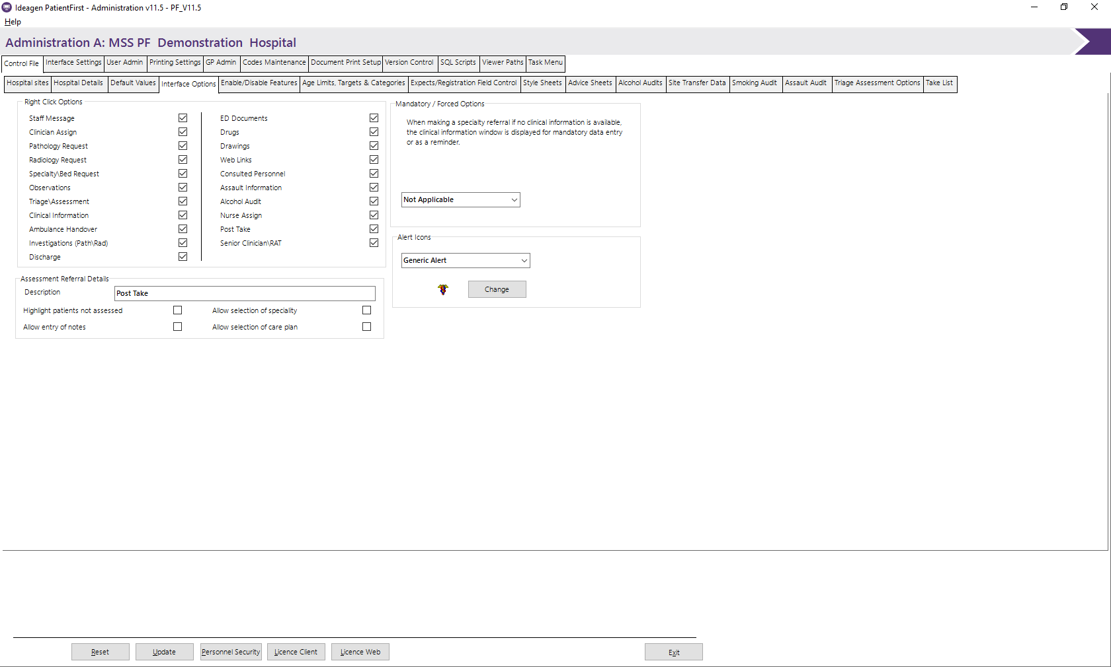

Right Click Options
Clicking any of these will enable the associated right click function to the PF Interface program. This does not affect the Location option of the right click function.

Mandatory Forced Options
The option controls whether the Clinical coding window is displayed prior to the selection of a speciality and whether this must be completed prior to progressing to the speciality selection screen.

Assessment Referral Details
The following options are only displayed if the Assessment Referral option is ticked in the Right Click Options panel and control the display of various functions to be activated in this function.

Enable/Disable Features
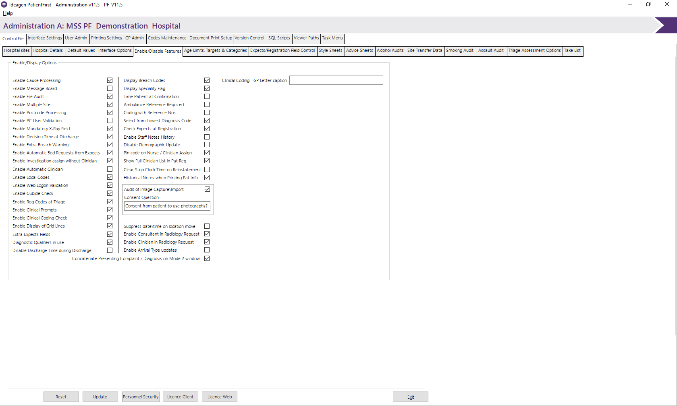

Enable/Display Options
The following options control the display of various functions and fields on both, Registration and Clinical Coding.

Enable cause processing
Specifies whether the ‘Cause processing’ field is displayed on the registration and triage screens.

Enable message Board
Specifies whether the ‘Message Board’ functions are to be used.

Enable File Audit
Specifies whether the file recording auditing should be activated.

Enable Multiple Site
Specifies whether the ‘Multiple Site’ field should be displayed on the Personnel Maintenance screen and Multiple Site details to be entered.

Enable Cubicle Check
Specifies whether the cubicle validation routine is activated in the PF_interface program.

Enable Registration Codes at Triage
Specifies whether registration code fields should be displayed on the triage entry screen.

Enable Clinical Coding Check
Specifies whether the system is to check if at least one Diagnostic or Treatment code has been used. If this is on and no Diagnostic or Treatment code has been used, a warning message will be issued when the patient is discharged.

Enable Clinical Prompts
Specifies whether Clinical prompts are to be made available.

Enable Postcode Processing
Specifies whether the postcode function is to be activated in Patient Registration.

Enable Decision to Admit Time at Discharge
Specifies whether the decision to admit time is activated on the clinical coding program.

Enable PC User validation
Enables the system to check that the PC logged on user is a valid PF user, as defined within User Admin.

Enable Automatic Clinician
Specifies whether the clinician prompt is automatically activated if/when the patient is selected in the PF_Interface and has not been coded for seen by Clinician.

Enable Local Codes
Specifies whether the Local Codes fields are to be displayed. This would allow the entry of a single local Code at Patient Registration and all Local Codes at clinical coding.

Enable Mandatory X-Ray Field
Controls whether the text in, the ‘Specify Information Required from Exam Requested’ on the Radiology Request Form is to be Mandatory.

Display Breach Codes
Specifies whether Breach codes are to be displayed at discharge.

Display Speciality Flag
Specialty Flag is to be displayed on the PF_Interface screens.

Time patient at Confirmation
This option is used to determine the time at which the patient’s arrival is recorded. If this option is enabled, the arrival time is recorded when the patient registration process is completed. Otherwise the time is recorded at the start of the registration process.

Select from Lowest Diagnosis Code
If checked this option will take the lowest level Diagnostic code selected, when coding out a patient. This option only applies if multi-level diagnostic coding is being used.

Ambulance Reference Required
If checked this option will enable the ambulance reference field if a patient’s mode of arrival in registration is by ambulance, and will prevent the user closing the registration if this value is not supplied.

Coding with Reference Nos
This allows for the display of the relevant code as well as the description on dropdown lists.

Enable Web Logon Validation
This allows for validation of the web logon.

Enable Automatic Bed requests from Expects
This allows automatic creation of a bed request if the patient is registered from patient expects with a specialty.

Enable Display of Grid Lines
This allows for the PF_Interface Mode 2 to be displayed with Grid Line.

Enable Extra Breach Warning
This enables a breach warning to be displayed in patient Clinical Discharge if the patient has breached.

Check Expects at Registration
This enables the patient registration program to check if the registered patient is in the patient expects file for the current period.

Enable Staff Notes History
This function enables the retention of all staff messages per episode.

Disable Demographic Update
This function currently prevents the update of the hospital number on Patient Demographic Patient Amendment.

Extra Expects Fields
This function enables the entry of additional data collection fields in the Patient Expects function.

Concatenate Presenting Complaint/Diagnosis on Mode 2 Window
This function allows the concatenation of Diagnosis and Presenting Complaint on the Mode 2 window of PF Interface,

Enable Investigation assign without Clinician
This function enables a nurse to record examination carried out without being assigned as the assigned clinician.

Enable PIN code validation on Nurse/Clinician Assign
This function allows the system administrator to define whether the Nurse/Clinician Assign requires the entry of the Personnel Code PIN number.

Show Full Clinician List in Pat Reg.
This function allows the system administrator to define whether the list of all Consultants is displayed on the Consultant dropdown list or only those Consultants who have a specialty for an ED Department.

Diagnostic Qualifiers in use
This function allows Diagnostic Qualifiers to be displayed when a Diagnosis is selected.

Disable Discharge Time During Discharge
This function disables the discharge time while the discharge process is being completed.

Clear Stop Clock Time on Reinstatement
This function will remove the previously assigned stop clock time when the patient is reinstated.

Historical Notes when Printing Pat Info
If checked the Triage/Clinician/GP notes fields will display all the historical notes with date/time and the related user code for the notes.

Audit of Image Capture/Import
Request the consent of the patient to take/use photographs.

Suppress date/time on location move
This function stops the date and time from being edited when moving patients.

Enable Consultant in Radiology Request
Enables the Consultant field within the Radiology request.

Enable Clinician in Radiology Request
Enables the requesting Clinician field within the Radiology request.

Enable Arrival Type Updates
Allows the arrival type to be updated within Clinical information or during the Discharge process.

Clinical Coding – GP Letter Caption
Add text to remind the Clinicians for anything pertinent during Clinical Coding.

Age Limits, Targets and Categories
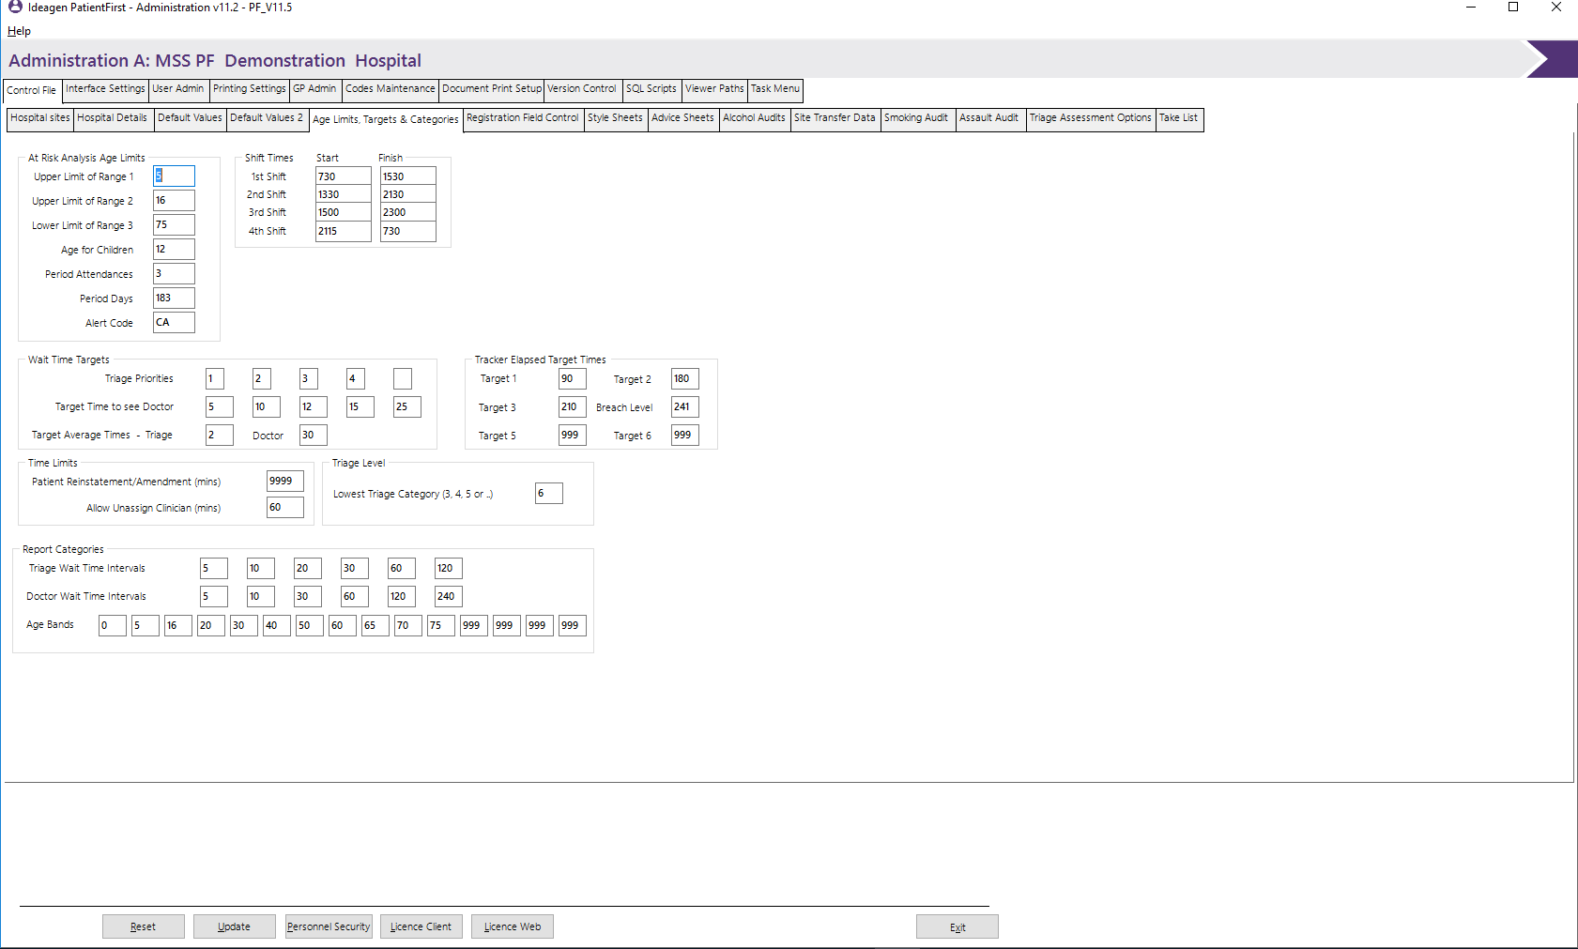
The Age Limits, Targets and Categories screen enables the administrator to set specific reports, screen target values and reporting age limits.

At Risk Analysis Age Limits
These fields specify the age groups, which will be used in the age limit reports and other internal calculations. Also, included in this panel are Period Attendances and Period days. These are to be utilised to identify Children who have attended department X number of times in Y of days plus a default alert code.

Shift Times
Specifies the start and finish times for each shift. Any shift times that are not required should be set to zero.

Wait Time Targets
Specify the target times in minutes for a patient to be seen by a Doctor for each triage priority category. The target average time for triage/doctor is the target time in minutes for all patients to have been seen respectively.

Tracker Elapsed Target Times
Specify the target times in minutes for Patient Tracker.

Time Limits
Specify the maximum time since patient disposal that the patient’s record can be reinstated or amended (now increased to 4 numeric). Also, a new value of Allow Un-Assign Clinician has been included which allows the Administrator to set the maximum time allowed for a clinician to un-assign themselves from a patient.

Triage Level
Specify the lowest level of triage category to be displayed on the Triage screen. Acceptable values are 3,4 or 5.

Report Categories
The triage and Doctor wait time intervals are used to determine the categories used in the wait time analysis reporting.

Age Bands
Certain reporting and data recording functions analyse patient episode data by age group. These age band fields determine the categories used in the reports. Any unwanted age bands should be set to 999.

Registration Field Control
The Code Type Prefix/Registration screen enables the administrator to select which code types are to be used and identify which registration fields are to be made mandatory.
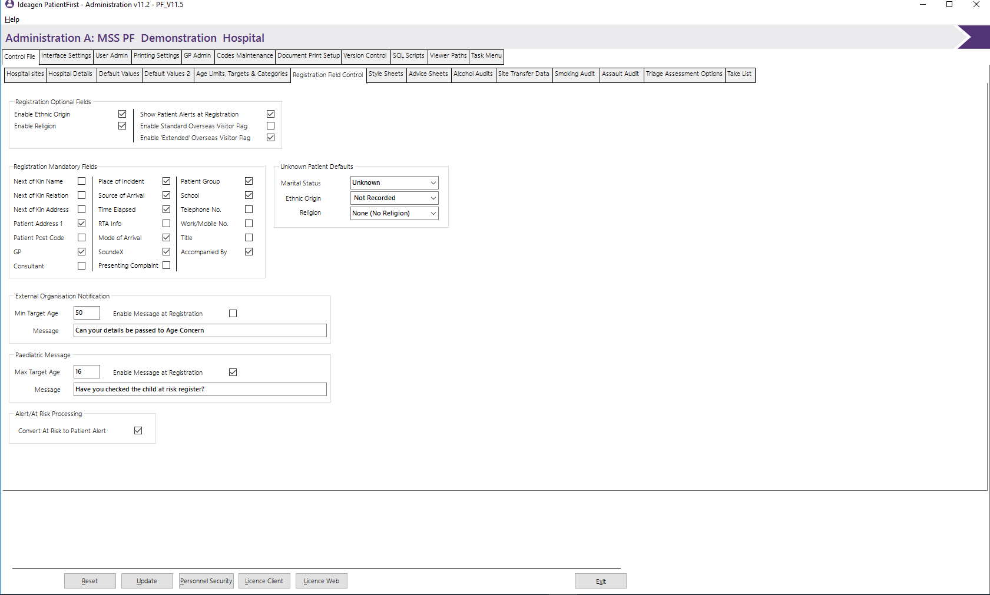

Registration Optional Fields
These fields allow you to select some of the fields for the patient registration program. Most fields are automatically used. The ones listed here can be turned on or off depending on your institutions preference for recording this data. The show Patient Alerts at Registration allows for the receptionist to be informed of any alert recorded against a patient.

Registration Mandatory Fields
The following options control whether the fields indicated require a valid value before further processing can continue. The school mandatory indicator will only apply to patients between the ages of 5 to 16.

Unknown Patient Defaults
The following options allow for the setting of default values for the fields Marital Status, Ethnic Origin and Religion. These values will only be used if the relevant field is selected as Mandatory.

External Organisation Notification and Paediatric Message
These options allow for the recording of patient’s response to the question in the Message box.

Style Sheets
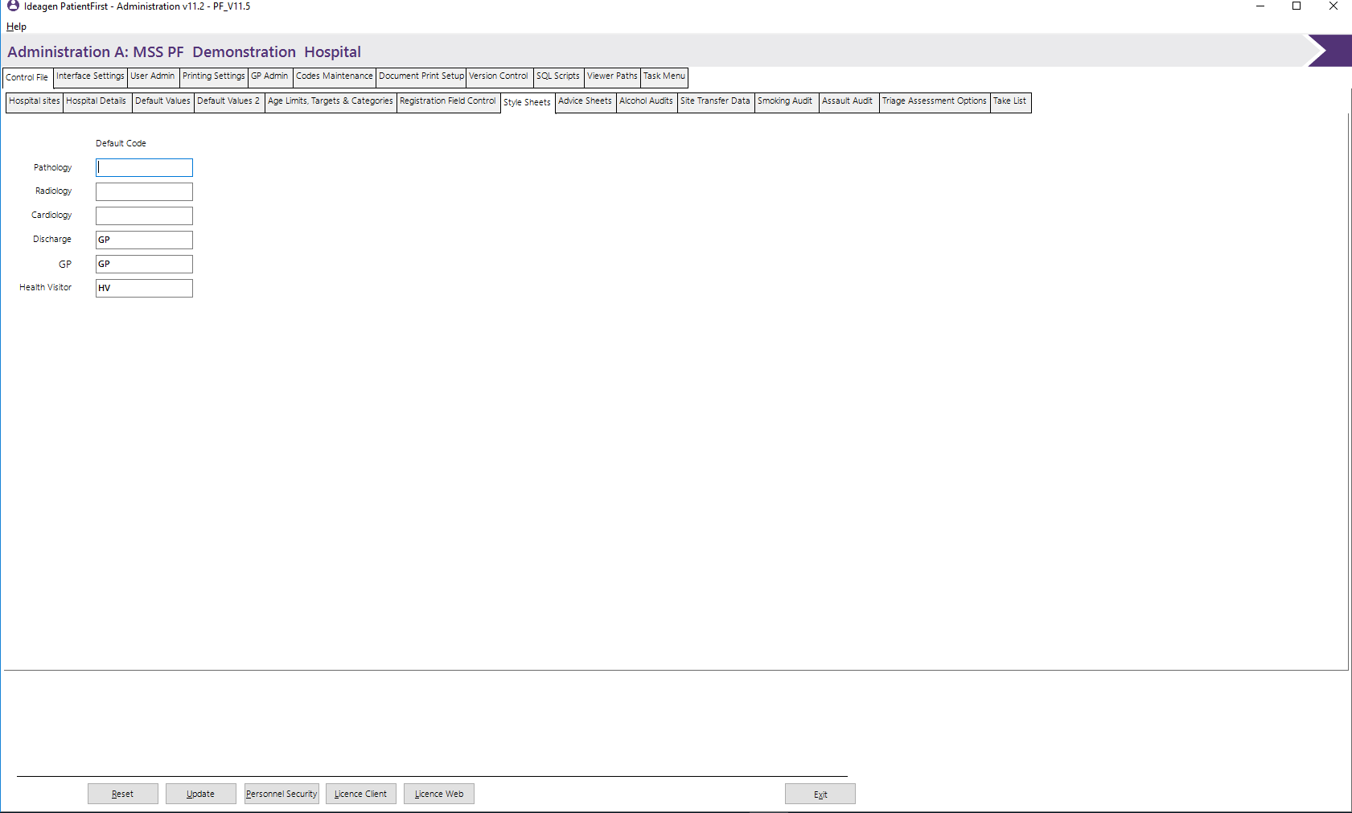
The style sheet screen allows the administrator to enter the codes of the relevant style sheets to be used.

Default Code
Enter the code to be used to identify the relevant style sheet. The codes can be found under the Discharge Letters & Formats {DSS} code type in codes maintenance. For example the Health Visitor field (HV) points to the HV code under DSS which then shows the path of the style sheet that will be used for the letter type.

Advice Sheets
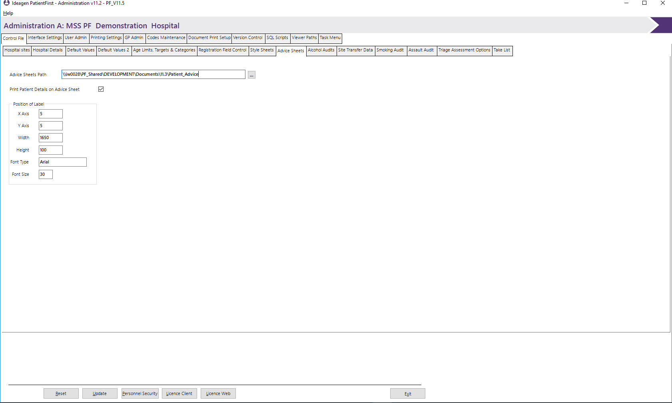
The Advice Sheets screen allows the administrator to enter the Path to be used to locate the Advice Sheets.

Advice Sheets Path
Enter the path where the style sheets are to be found.

Print patient’s details on Advice Sheet
Enable this option if the patient’s details are to be printed on the Advice Sheets.

Position of Label
This Panel will only be displayed if the Print patient’s details on Advice Sheet has been ticked, the fields within here allow you to customise label’s position and text font/size.

Alcohol Audits
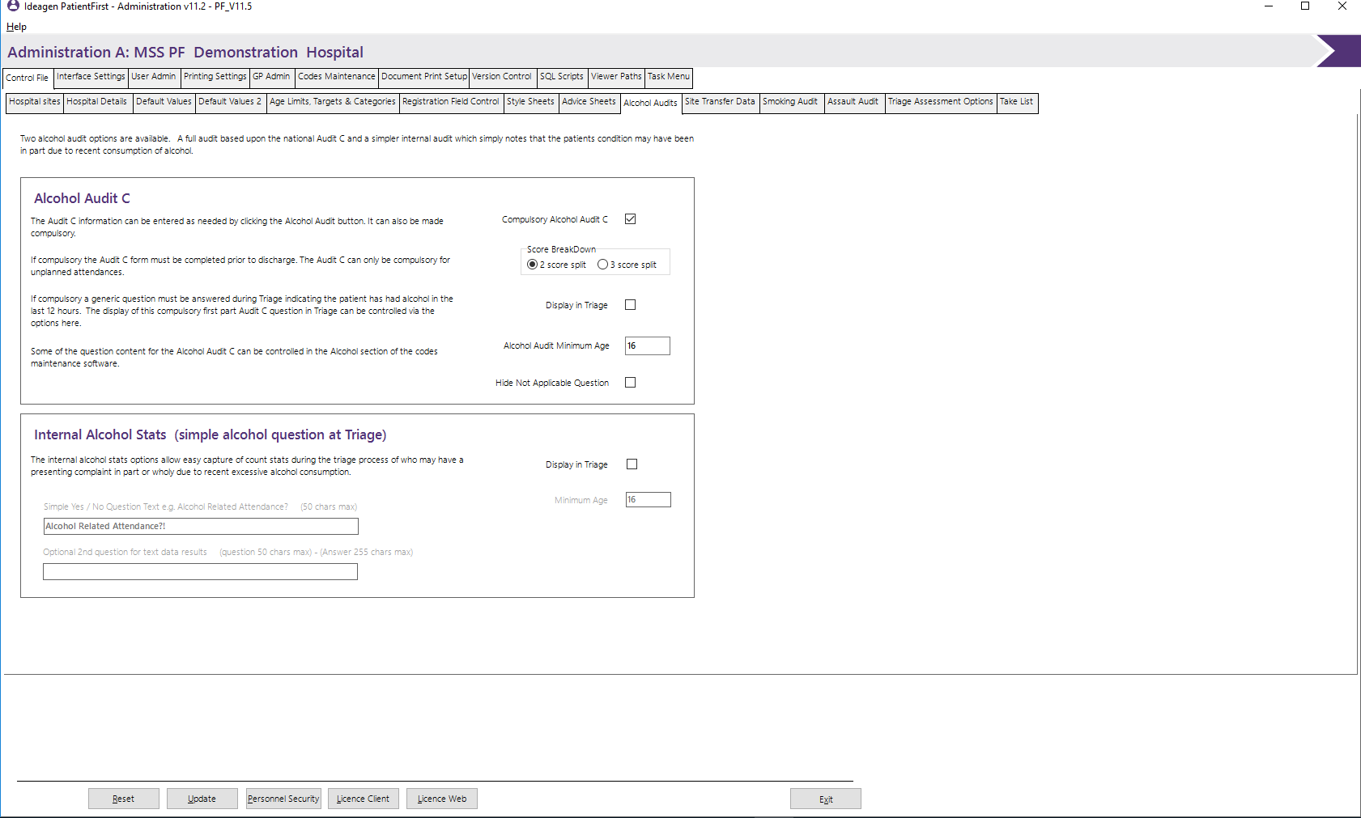
The Alcohol Audits screen allows the administrator to enter the values that control the display of values that appear in the system relating to Alcohol Audit screens and questions.

Alcohol Audit C
Please see the detailed information on the Alcohol Audit C section.

Site Transfer Details
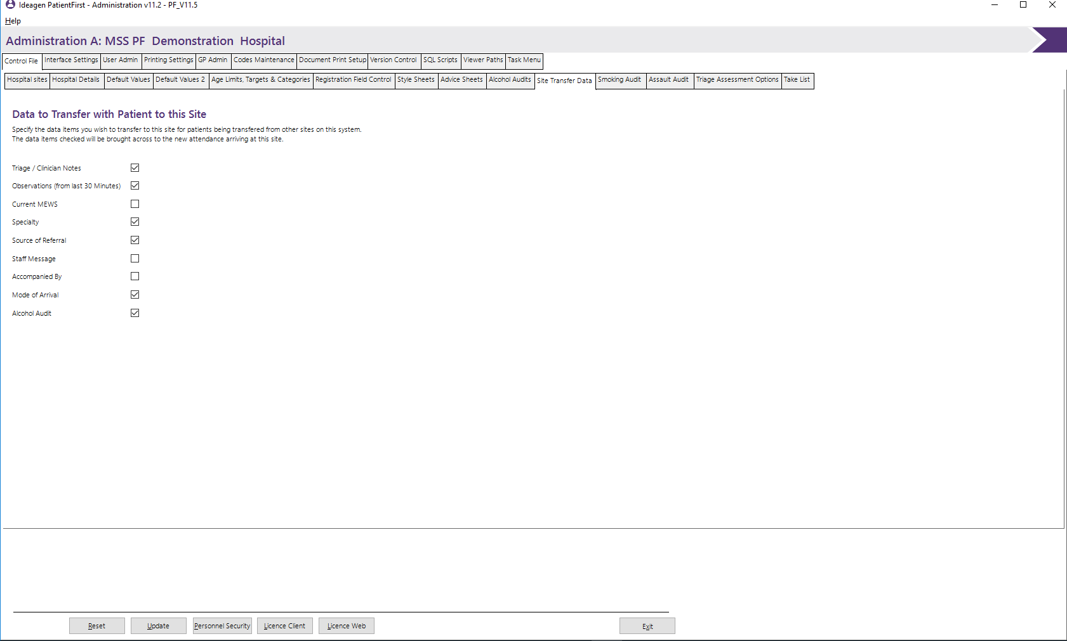
The Site Transfer Details screen allows the administrator to select the data elements that are to be copied to the new attendance that is created when a patient is received at a target site as defined in the location relevant location record.

Smoking Audit
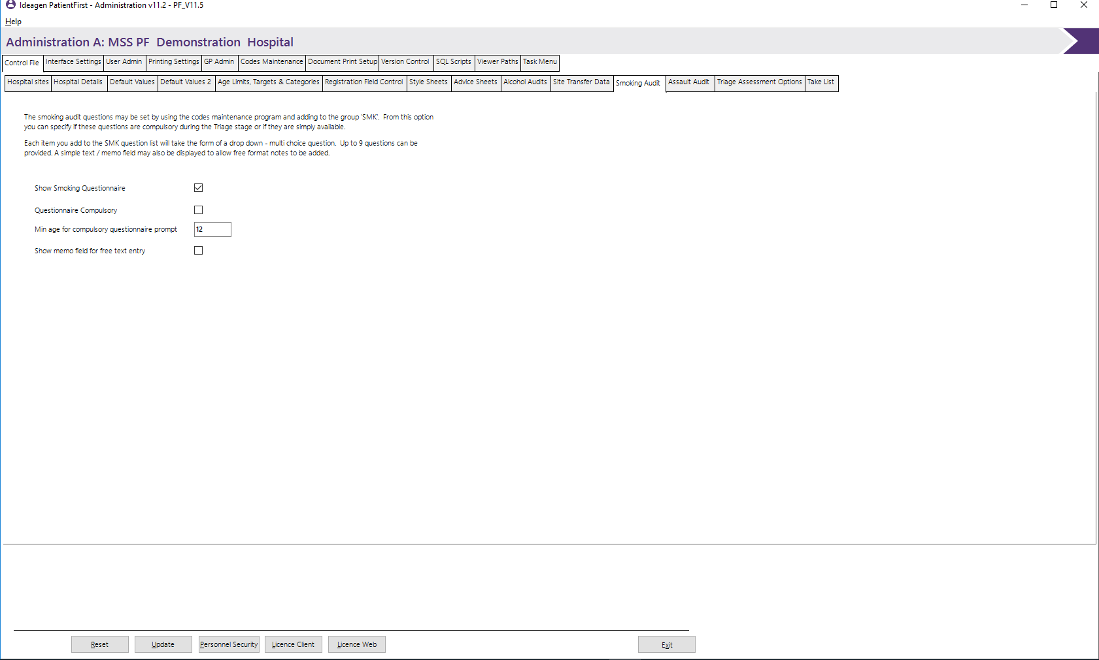
The Smoking Audit screen allows the administrator to select the options and parameters controlling the display of the smoking audit.

Assault Audit
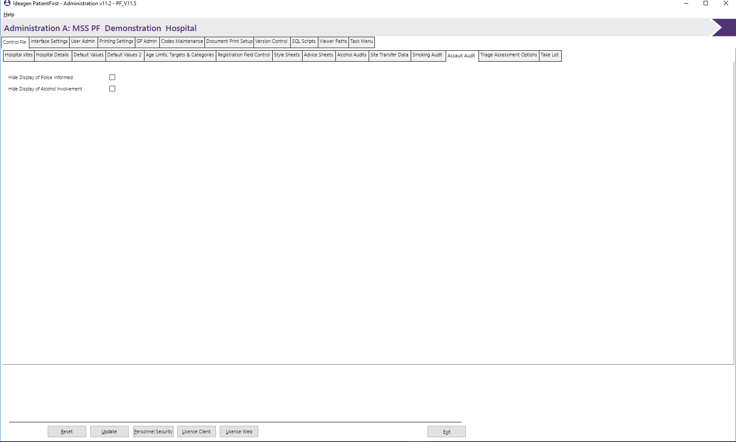
The Assault Audit screen allows the administrator to select values that could be excluded from the Assault audit screen.

Triage Assessment Options
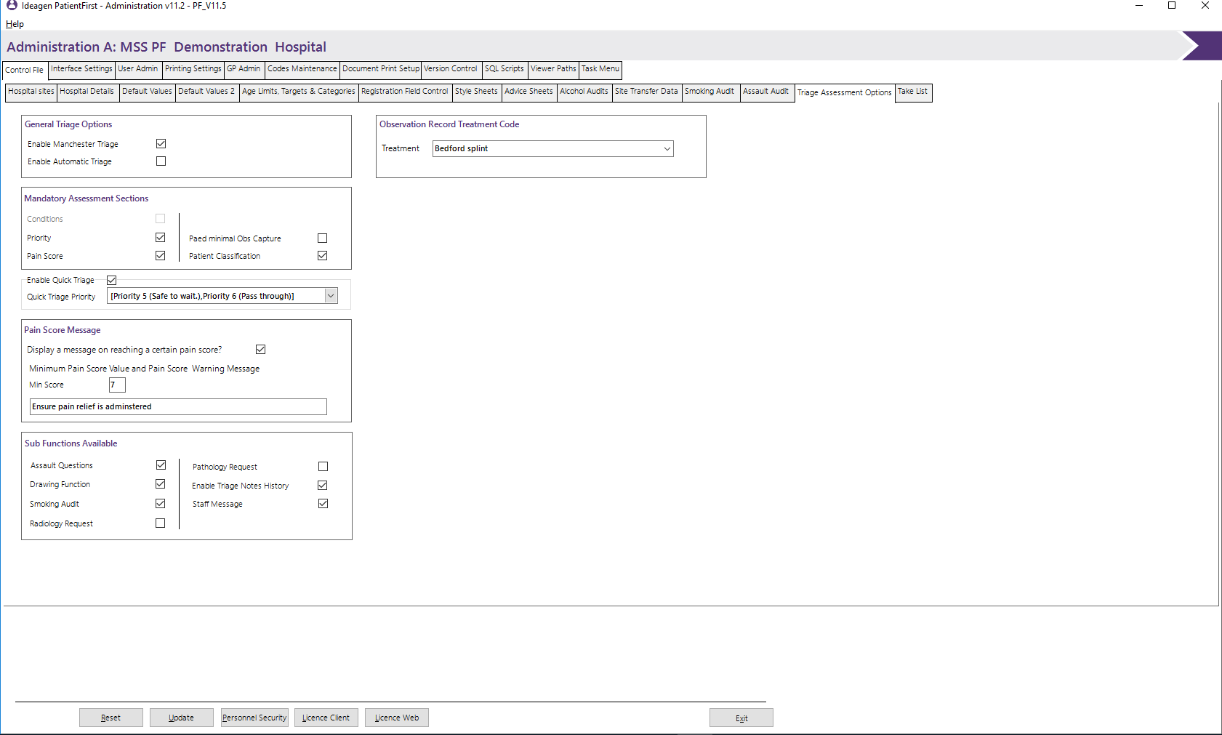
The Triage Assessment Options screen allows the administrator to select the data elements that are to be displayed and which are to be defined as mandatory.

General Triage Options
The following options control the type of triage assessment being used and the automatic function of triage call if required.

Enable Manchester Triage
Specifies whether the Manchester Triage process is to be used, if not selected the conditions function on Assessment will not be displayed.

Enable Automatic Triage
Specifies whether the triage prompt is automatically activated when the patient is selected in the PF_Interface, has not been triaged.

Mandatory Assessment Section
The following options control the triage function that are mandatory and have to be completed before the user is allowed to continue, these are: Conditions (if Manchester Triage is enabled), Priority and pain Score.

Enable Quick Triage
This option controls whether a quick triage is in use. This enables the triage/assessment process to bypass all mandatory processing, with the exception of priority and the value in Quick Triage priority will be the default priority.

Pain Score Message
The following options control whether a Pain Score Message is to be sent, the achieved score that triggers the message and the message that is to be displayed.

Sub Functions Available
The following options control which additional functions are available on assessment, these could be in the form of additional buttons at the bottom of the screen or additional tabs.

Interface Settings

PAS/PMI
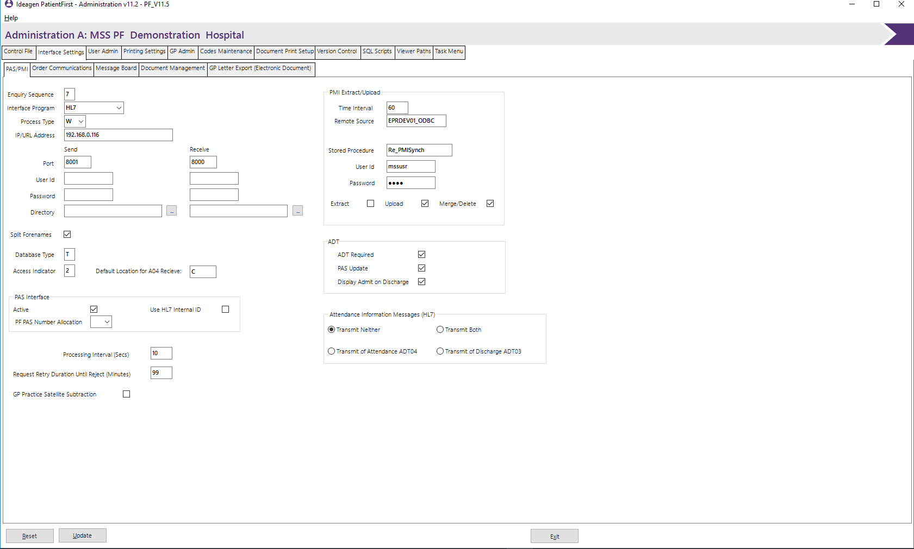
The PAS/PMI screen allows for the entry of values pertaining to any PAS/PMI interface in use by the hospital. This screen will need a certain amount of technical information available to the user, such as IP addresses port numbers and ODBC data source etc.

Enquiry Sequence
Specifies the sequence in which patient demographic searches are made in the registration process. Valid values are:-
2- The Local A&E database is searched first followed by the remote PAS
4- Only the remote PAS enquiry is displayed.
6- The Local A&E enquiry is displayed first followed by the local PMI enquiry.
7- The Local PMI enquiry is displayed first followed by the local A&E enquiry.
8- Only the Local PMI enquiry is displayed.
N- AEMST look up only. (no remote PAS or local PMI)

Interface Program
Specifies the name of the interface program to be used, this can be selected from a dropdown list. Supplied from Code Detail records type ITS.

Process Type
Specify the interface processing type valid options are:-
F- FTP
W- Web Service
These options can be selected from a dropdown list.

IP/URL Address
This may be the IP Address or URL dependant on the type of interface being utilised.
The following values only apply if the Process Type of F (FTP) has been selected.

Send / Receive

Process interval
Specify the Processing Interval in seconds.

Port
Specifies the port being used to send/receive messages/data from the remote PAS/PMI.

User ID
Specifies the User ID to be used to connect to the remote PAS system for sending/receiving messages/data.

Password
Specifies the password to be used in conjunction with the user ID to connect to the remote PAS system for sending/receiving messages/data.

Directory
Specifies the Destination/Retrieval directory for sending/receiving messages/data or use the browse function.

Database Type
Specifies the type of database being utilised, valid options are:-
T- Training
L- Live

Access Indicator
Specifies the type of access required to the remote PAS/PMI system. Valid options are:-
‘1’- Access Live database, no update.
‘2’- Access Live database, update allowed.
‘3’- Access Training database, no update.
‘4’- Access Training database, update allowed.

PAS Interface
Specifies whether the PAS interface is required.

PF PAS Number Allocation
Specifies the type of source of PAS numbers if a block is allocated to PatientFirst. Valid options are:-
Blank- No allocation of PAS numbers within PatientFirst.
A-Allocation is from the prime site.
3- Access Training database, no update.
4- Access Training database, update allowed.

PMI Extract/Upload
This panel contains the values required for PMI Extract/Upload.

Time Interval
Specify the Extract/Upload Time Interval in seconds.

Store Procedure
Specifies the name of the stored procedure to be used, to carry out the Extract/Upload.

Remote Source
Specifies the name of the ODBC data source to be used to connect to the PMI database.

User ID
Specifies the User ID to be used to connect to the remote PMI for the Extract/Upload function.

Password
Specifies the Password to be used in conjunction with the user ID to connect to the remote PMI for the Extract/Upload function.

Extract
Specifies whether the Extract function is to be used.

Upload
Specifies whether the Upload function is to be used.

Merge/Delete
Specifies if the Patient Merge/Delete function is to be used.

ADT

ADT Required
Specifies whether the ADT function is to be used.

PAS Update
Specifies whether the PAS system is to be updated with PatientFirst Admission data.

Display Admit on Discharge
Specifies whether the Admission screen is to be displayed when a patient is moved to an ADT location.

Attendance Information Messages(HL7)
This panel will only be displayed if the Interface program HL7 has been selected.

Transmit Neither
This is to be ticked if neither of the two forms are required for transmission.

Transmit Both
This is to be ticked if the transmission of both forms is required.

Transmit of Attendance HL704
This is to be ticked if the HL7 form 04 is to be transmitted to the PAS system.

Transmit of Discharge ADT03
This is to be ticked if the ADT03 form is to be transmitted to the PAS system.

Order Communications
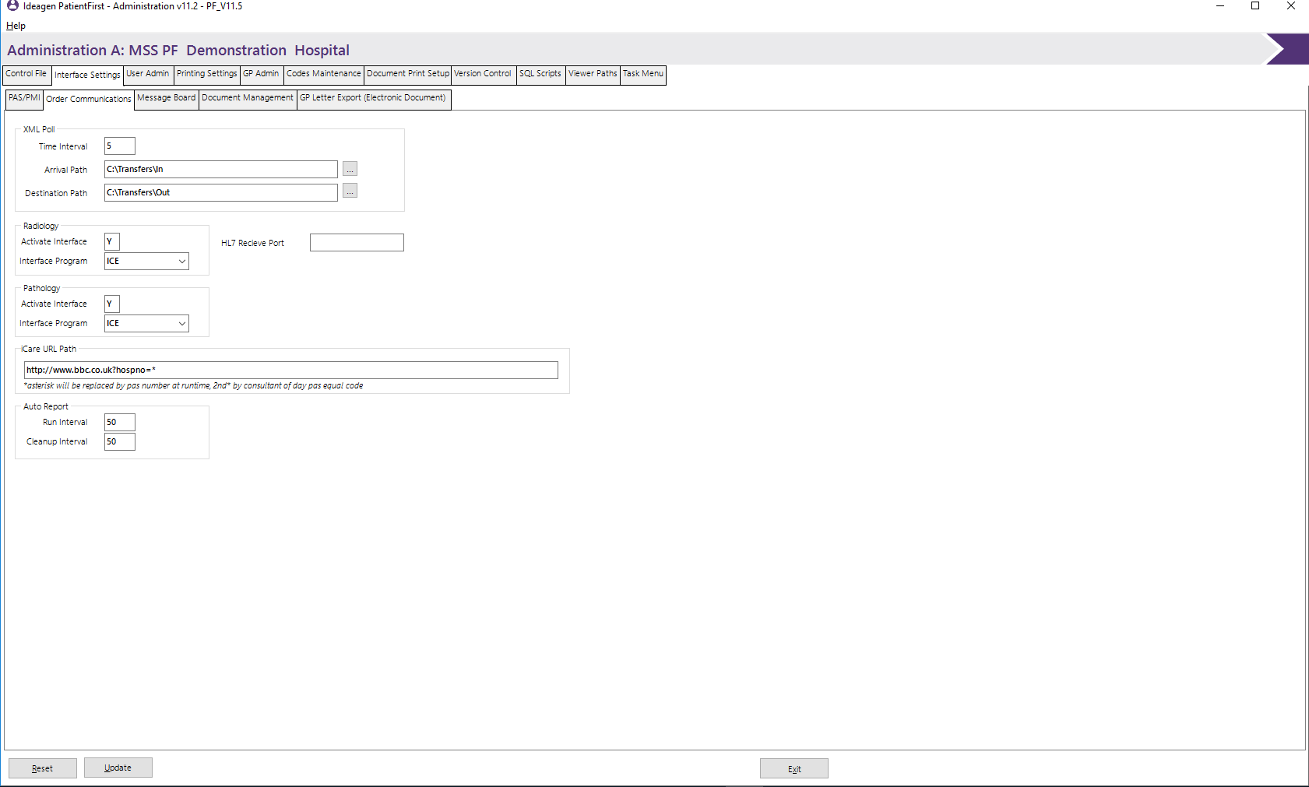
The Order Communications screen allows for entry of values pertaining to any order Communications required by the system.

XML Poll

Time Interval
Specify the XML Poll Time Interval in seconds.

Arrival Path
Specifies the server directory to store incoming data. Either key in the path or use the browse function.

Destination Path
Specifies the server directory to store Outgoing data. Either key in the path or use the browse function.

Radiology / Pathology Interfaces
These fields are used to define any Radiology and Pathology interface/Order Comms interface. If left blank the system will assume that no Pathology/Radiology interfaces are active.

Auto Report

Run Interval
Specify the Time Interval in seconds that the monitor checks for Automated Reports.

Cleanup Interval
Specify the Time Interval in seconds that the Report Cleanup function runs.

Message Board
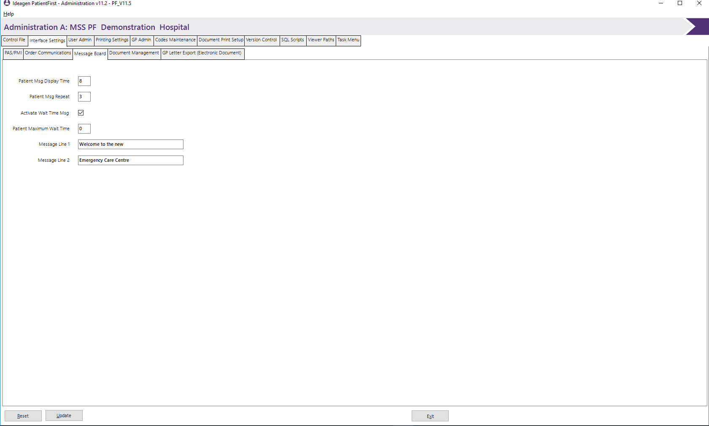
The message Board screen allows for the entry of values pertaining to the Message Board if in use. This screen will need a certain amount of technical information available to the user, such as IP addresses and port numbers.

Patient Msg Display Time
This field contains the number of seconds a patient message is displayed for before being replaced by the wait time message if active, or any other message.

Patient Msg Repeat
This field contains the number of times the Patient message is to be repeated.

Activate Wait Time Msg
Click on if the wait time message is to be displayed.

Patient Maximum Wait Time
Enter the current maximum wait time, this will be integrated into the wait time message.

Message Line 1
Enter text to appear on line one of the message board.

Message Line 2
Enter text to appear in line two of the message board.

Document Management
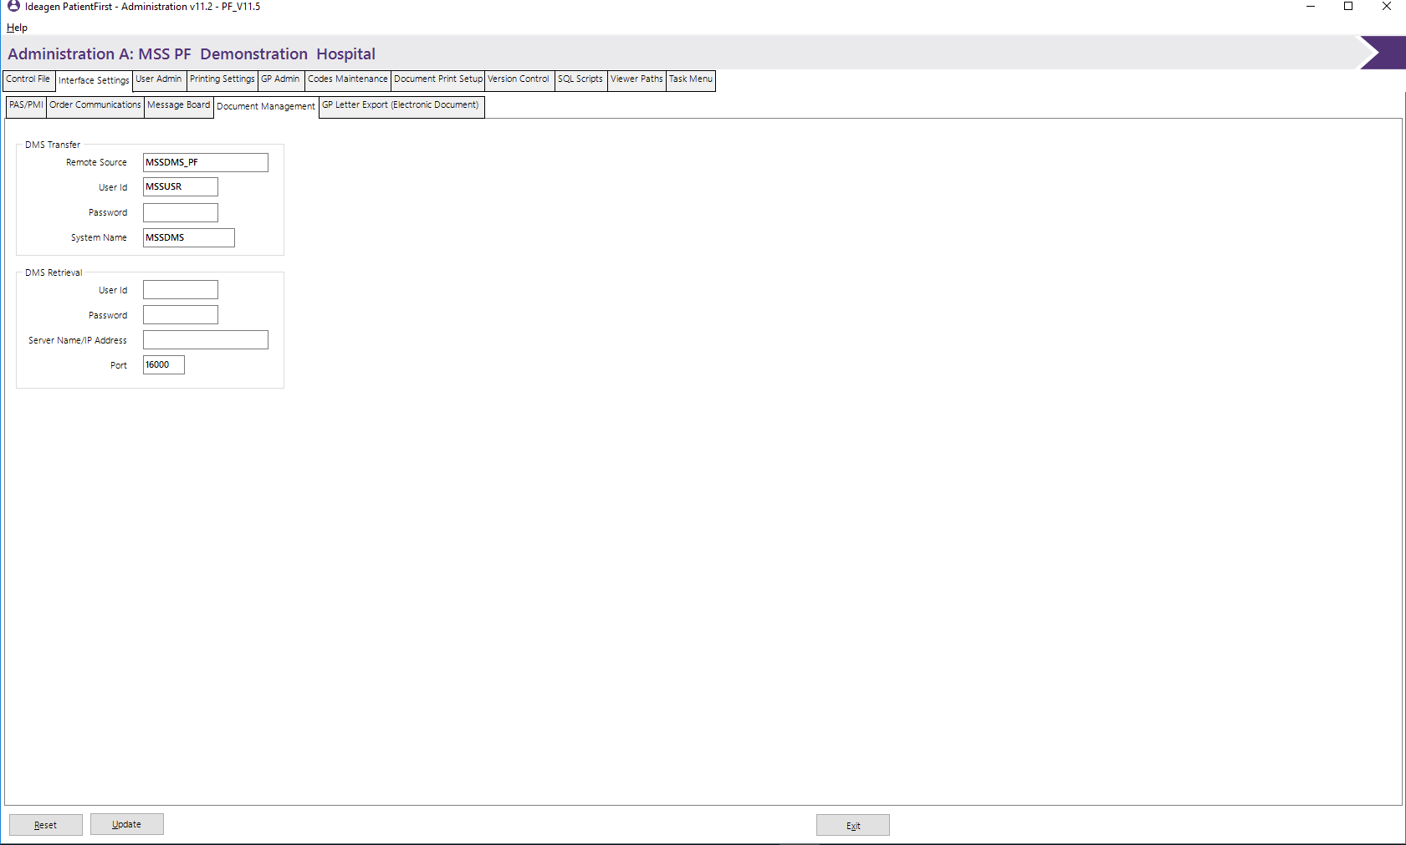
The Document Management screen allows for the entry of values pertaining to the Document management system. This screen will need a certain amount of technical information available to the user, such as IP address, SQL server names and ODBC data source etc.

DMS Transfer

Remote Source
Specifies the name of the ODBC data source to be used to connect to the DMS database.

User ID
Specifies the user ID that is going to be used to connect to the remote DMS database.

Password
Specifies the password to be used in conjunction with the User ID.

System Name
Specifies the name of the system as known by DMS. MSS strongly recommend that this remains as MSSDMS.

DMS Retrieval

User ID
Specifies the User ID that will be sued to connect to the DMS server to retrieve documents.

Password
Specifies the password to be used in conjunction with the User ID.

Server Name/IP Address
Enter the name or IP Address of the DMS server.

Port
Enter the port number to be used to receive documents from the DMS server.

GP Letter Export (Electronic Document)
The GP Letter Document Export screen allows for the entry of values pertaining to the production and storage of GP Electronic Letters functionality.

XML Electronic Document
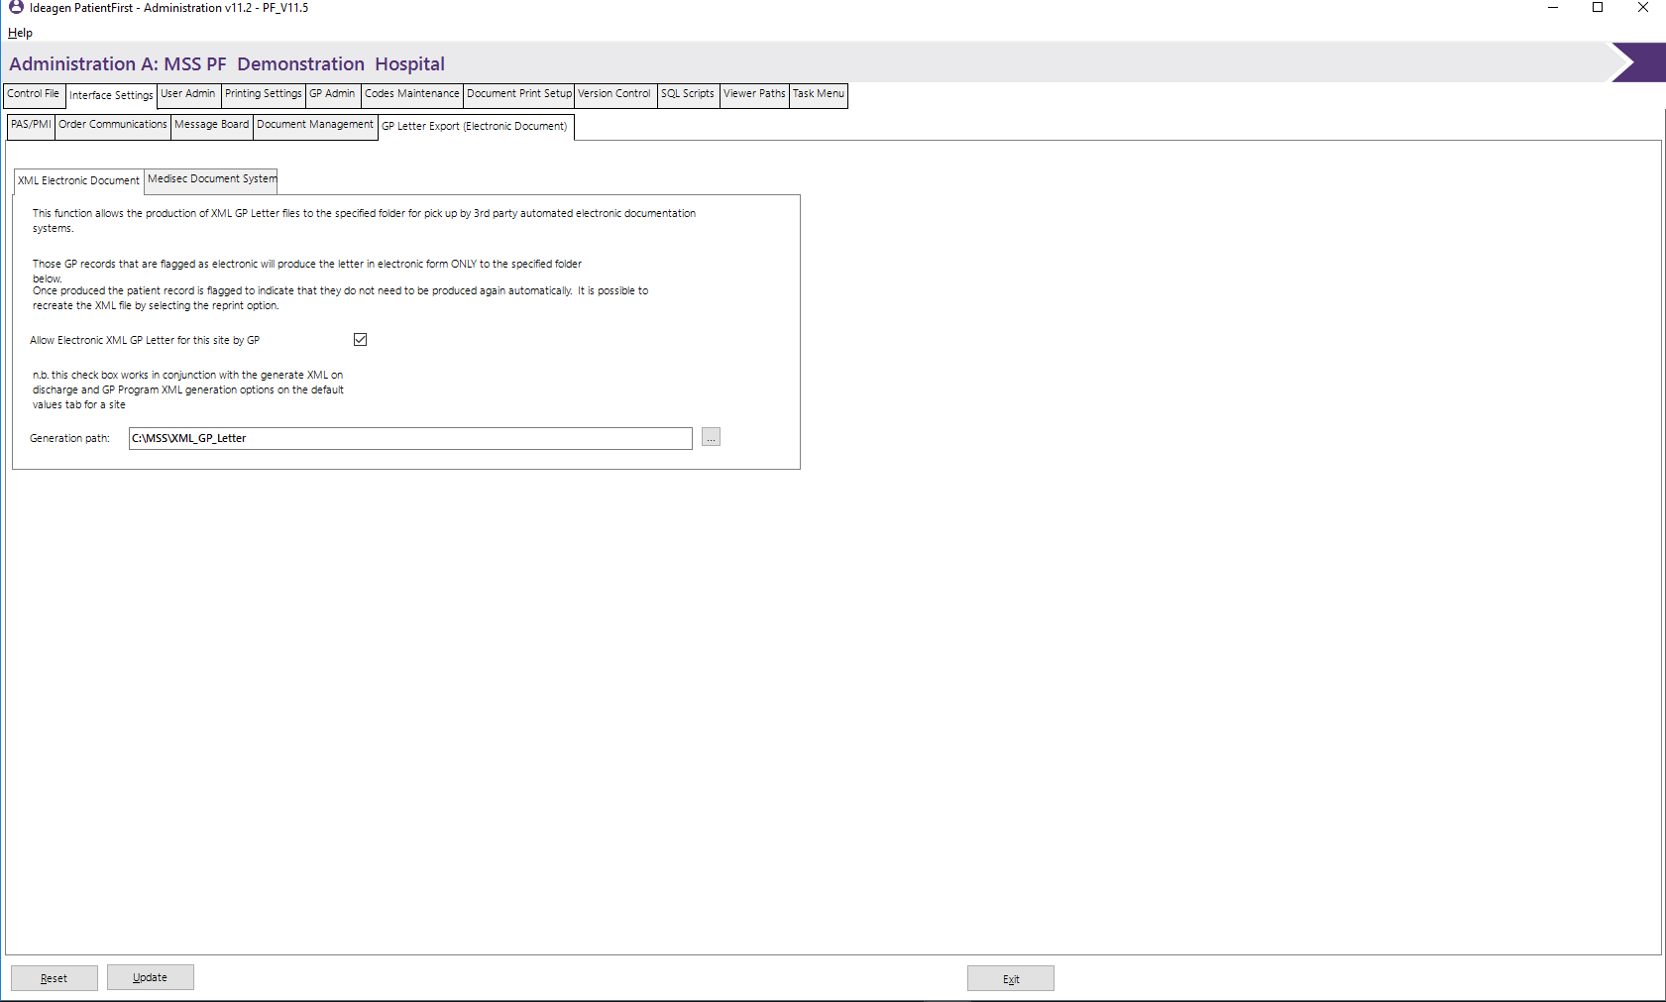

Allow Electronic XML GP Letters for this site by GP
Select this option if the electronic letter is to be produced as part of the GP Letter batch print process.

Generation Path
Enter/browse the server path where the electronic documents will be stored.

Medisec Document System
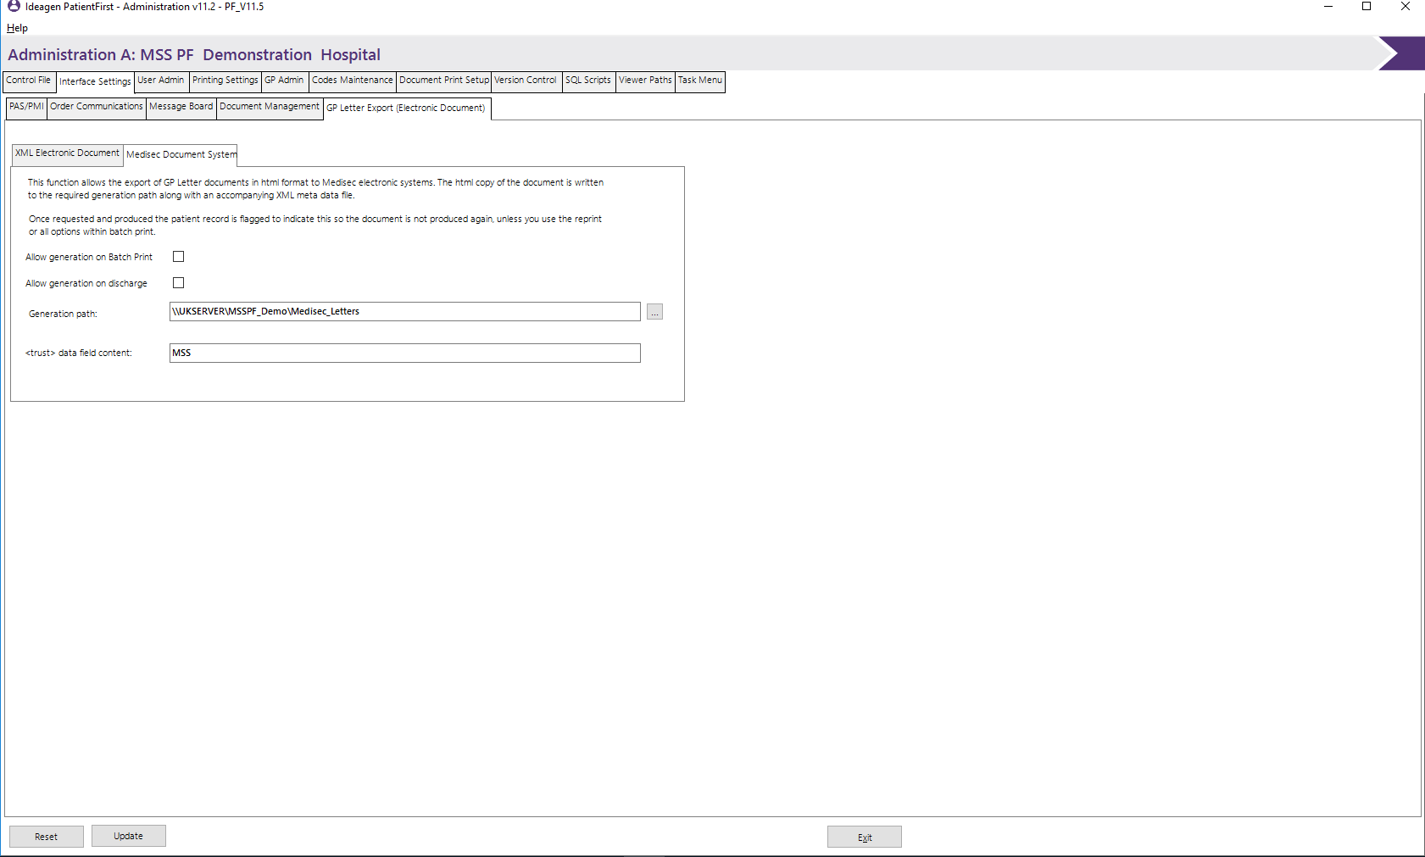

Allow generation on discharge
Select this option if the electronic letter is to be generated when the patient has been discharged.

Allow generation on Batch print
Select this option if the electronic letter is to be produced as part of the GP Letter batch print process.

Generation Path
Enter/browse the server path where the electronic documents will be stored.

<trust> data field content
Enter the value to be used for this option.

User Admin
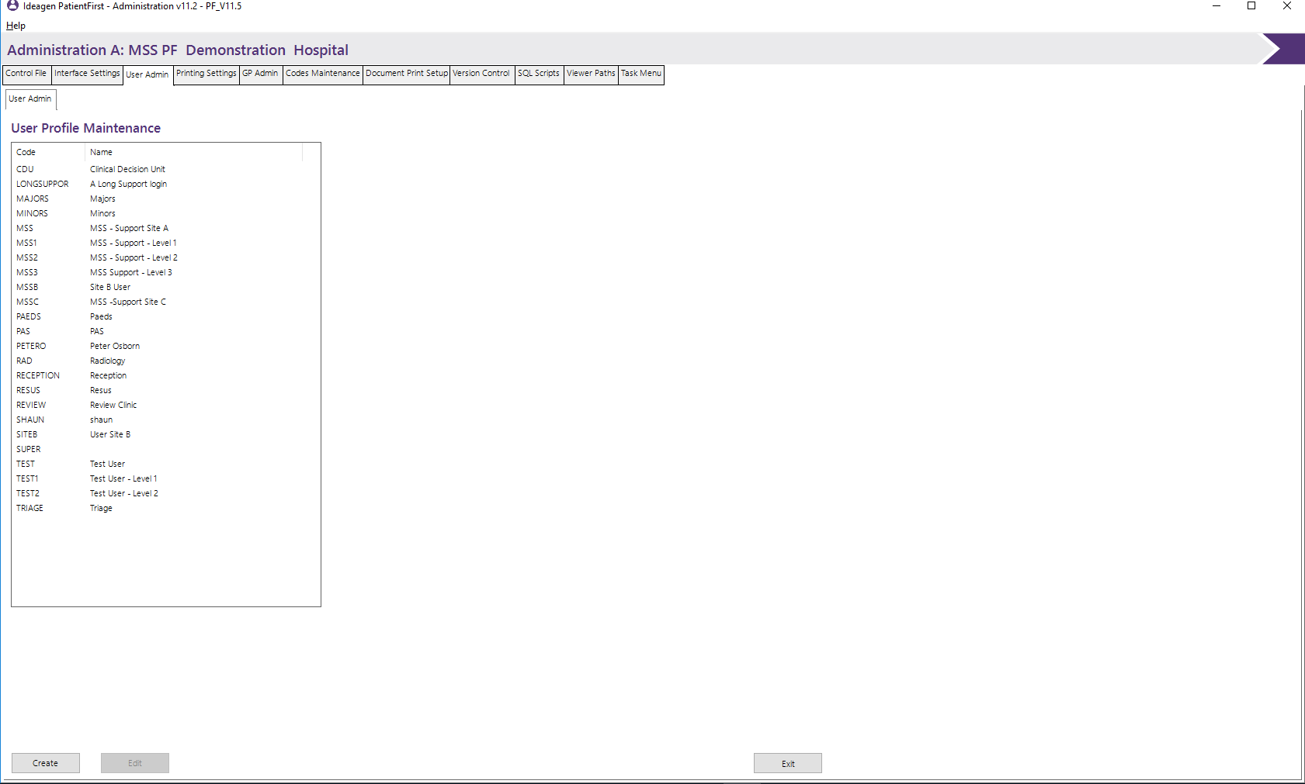
The User Admin screen allows for addition, update and deletion of user admin records on the admin master file.

To edit an existing record the user can either double click (or single click and click on edit) on the required record to display the current details. The details of that record will be displayed in the panel to the right. When finished updating click on the update button.
To delete a record, first open the editing window and then select delete.
Click on create for a new record, the empty admin maintenance screen is then displayed to the right.
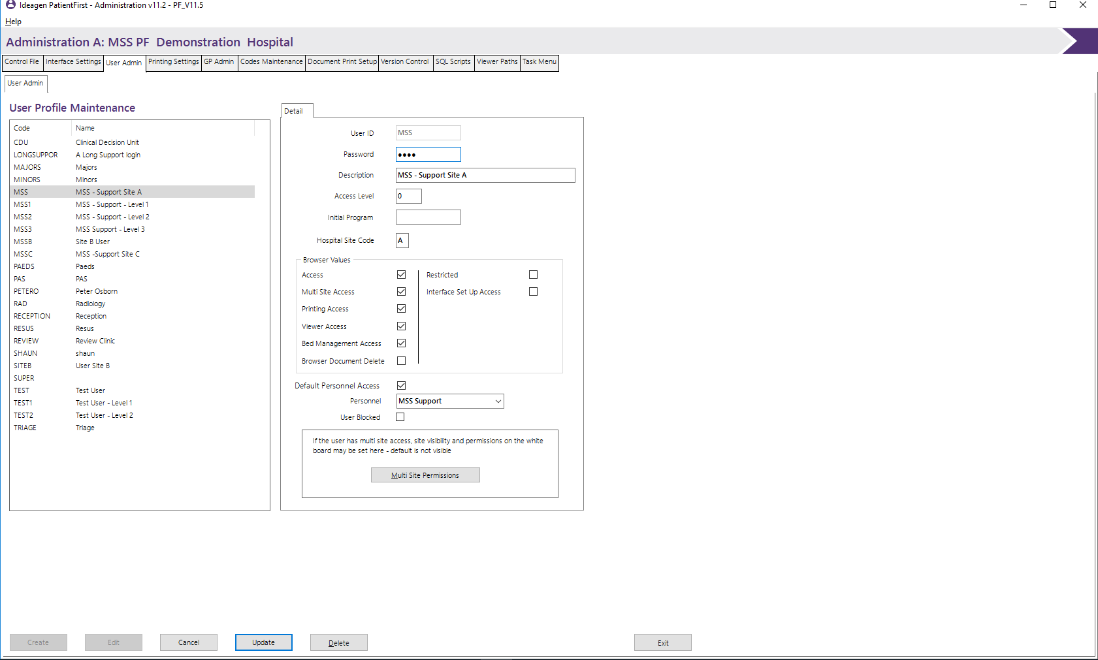

User ID
Enter a unique User ID this is normally derived from the User’s name.

Password
Enter a password that allows the user profile to sign onto the system. Specify up to 10 characters for the password. The content of this field will be hidden.

Description
Enter a description, which briefly describes the user profile.

Access Level
Enter the access level associated with the user profile. The access level is used to determine the menus/options to which the user has access. Valid levels are:-
‘0’- This is the highest level and allows access to all functions within the PatientFirst System.
‘1’- This level allows access to all functions except for the Control File function.
‘2’- Users with this level have access to all functions except for the Control File function and Service Admin.
‘3’- Allows access to all functions except for the Admin area.
‘4’- Allows access to all functions except for the Admin area.
‘5’- This is the lowest level of authority and only allows the user to the enquiry function.

Initial Program
Enter the program to be called when the user logs on.

Hospital Site Code (If applicable)
Enter the Hospital site code. In the case of users with access to multiple sites, enter the ‘Home@ Site code.

Browser Values

Access
Click on if the user is allowed access to the Web Browser.

Restricted
Click on if the user is allowed restricted access only to the Web Browser. This will only allow the user access to the patient demographic data.

Interface Set Up Access
Click on if the user is allowed access to the set-up function of PF_Interface. This will be allowed regardless of the user’s Prime access level.

Multi-Site Access (If applicable)
Specifies whether the user has access to multi-site information. Valid options are:-
‘Y’- multi site access is allowed.
Blank- Multi site access is not allowed.
The multi-site permissions panel allows the selection and access types of other sites that the user has access to on the whiteboard.
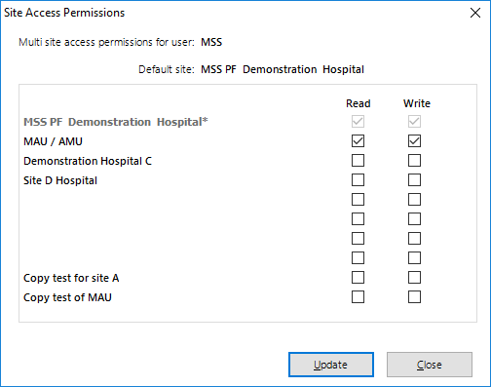

Printing Access
Click on if the user needs to have access to the print functions of the document viewer and web browser.

Viewer Access
Click on if the user needs to have access to the document viewer function.

Browser Access
Click on if the user is to have access to the Web Browser.

Bed Management Access
Click on if the web user is to have access to the Bed Management Function.

Browser Document Delete
Click on if the web user is to have the function to delete scanned patient documents.

Default Personnel Access
Click on if the user is to have a default Personnel code to allow automatic access to the PatientFirst system.

Personnel
Select the default user for this record, used when accessing the web browser so that the login screen is not displayed, prior to opening the browser.

User Blocked
Click here to block or un-block a user logon.

Personnel Maintenance
This Personnel Maintenance screen allows for addition, update and deletion of personnel records on the Personnel Master File.
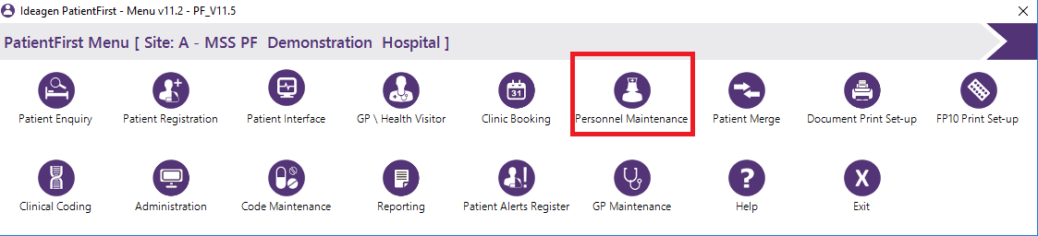

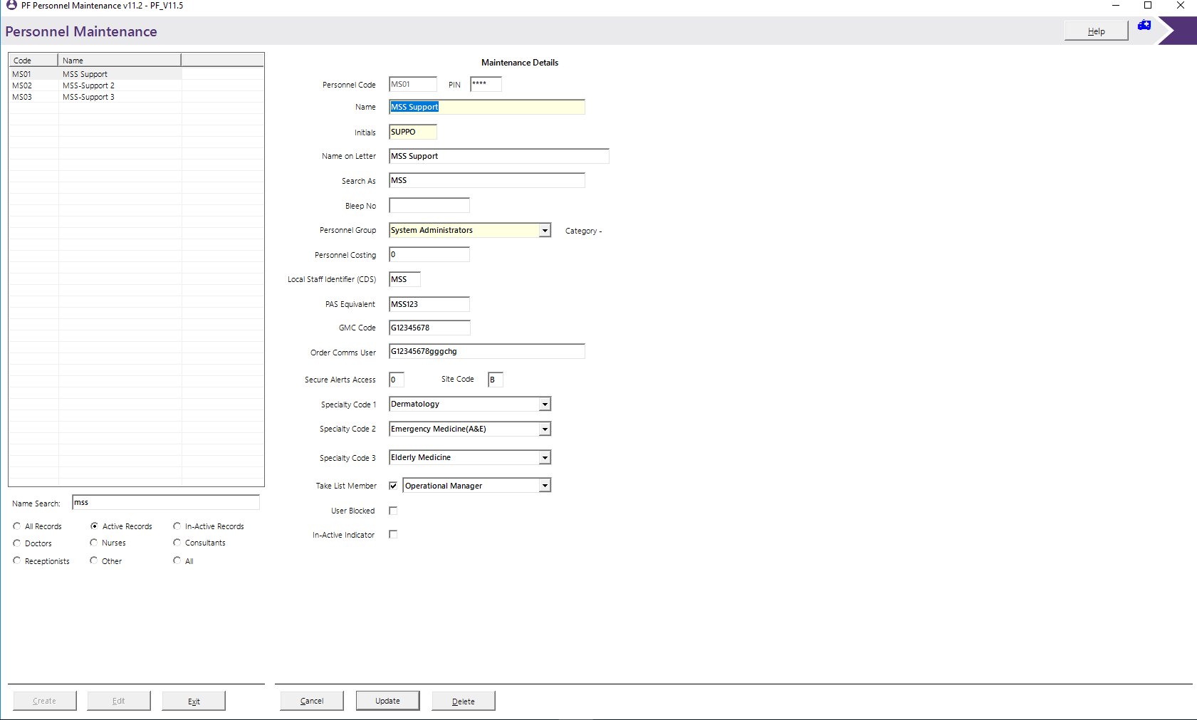

To edit an existing User record double click (or single click and edit) on the required record. The details for the selected record will be displayed in the panel on the right. When finished updating click on the update button.
To delete a record, first open the editing window and then click delete.
Click on create for a new record, the empty admin maintenance screen is then displayed on the right.
The search function will search the entire name value for the entered value.

Personnel Code
Enter the personnel code to be allocated to the staff member.

Name
Enter the name of the person.

Initials
Enter the initials of the person, these will appear on the white board in the clinicians column.

Name on Letter
Enter the name of the person, in the format required to print at the bottom of any letters, which will be signed by them.

Search As
Enter the value that will assist in finding the user on the search screen.

Bleep No
Enter the bleep number of the person.

Personnel Group
Select from the drop-down list, the appropriate personnel grouping. The values in this list are supplied by code type, Personnel Type (PTY) from the Codes file. The ‘Category’ field alongside will display the PatientFirst internal personnel category, which is the Equiv 1 value on the PTY codes detail record.

Personnel Costing
Enter the costing of the person in £££££.pp format if costing information is being held. Unless the figure is an exact number of pounds enter the decimal point and the number of pence.

Local Staff Identifier (CDS)
This field is used for CDS reporting purposes. It must contain a unique code and be no more than three characters in length.

PAS Equivalent
This field is used for the interchange of HL7 records between the PatientFirst system and the PAS system and this should contain the PAS Equivalent personnel code for the selected record.

Order Comms User
This field is used for the interchange requests between the PatientFirst system and the Pathology/Radiology order system and should contain the Order Comms Equivalent personnel code for the selected record.

Security Alert Access
Enter the Alert Access level for patient specific alerts. Values are:-
Blank- no access.
‘0’- Full Access.
‘1’- Limited Access.

Site Code
Enter the site code to which personnel is allocated.

Speciality Code 1,2 and 3
Enter the speciality codes to which the personnel is associated with.

User Blocked
Click on to block or un-block a personnel code.

In-Active Indicator
Tick this box to disable the personnel code. This allows you to temporary disable a user’s login, rather than deleting the record and having to recreate it later.

Printing Settings
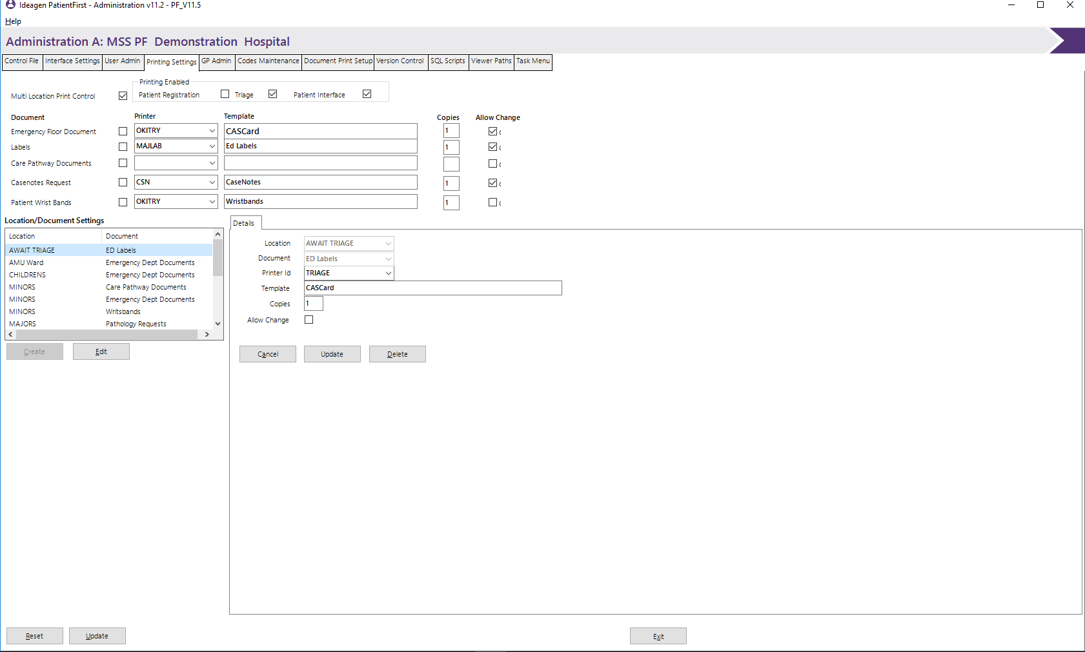
The Printing Settings screen allows the administrator to define the documents, printers and templates to be printed at the various locations within the Emergency Department.

Multi Location Print Control
Select this function to enable multi location document printing. Clicking on this option will also activate the multi location maintenance function.

Printing Enabled
This section enables the administrator to identify which functions enable printing. Clicking on the relevant function will cause the print documents window to be displayed.

Document
Click on the documents selected for utilisation. To de-select, click on the document to turn off the tick.

Printer
Select from the drop-down list, the printer to be used for this document and this location.

Template
Enter the name(s) of the Template to be used for this document. If more than one template is to be used, they must be separated by a comma.

Copies
Enter the number of copies required for the selected documentation/location.

Allow Change
Click on this if the value is allowed to be changed.

Where Multi location printing is not used, this information will be stored as location’*’.

Location / Document Settings Maintenance
This section will only be displayed if the multi location print control option has been selected. This selection allows for the creation, update and deletion of location document settings records in the Printing settings file. To edit an existing record double click *or single click and edit) on the required record, or you can click and create for a new record, the maintenance screen is then displayed. If a new record is being added, all input fields will be blank. If a record is being updated all current details are shown.

Location
Select from the drop-down list which location is to be used.

Document
Select from the drop-down list which document is going to be used at this location.

Printer
Select from the drop-down list which printer is going to be used for this document and location.

Template
Enter the name(s) of the template to be used for the document. If more than one template is going to be used for this, they must be separated by a comma.

Copies
Enter the number of copies required for the selected document/location.

Allow Change
Click on this if the value is allowed to be changed.

GP Admin

Define Local GP’s
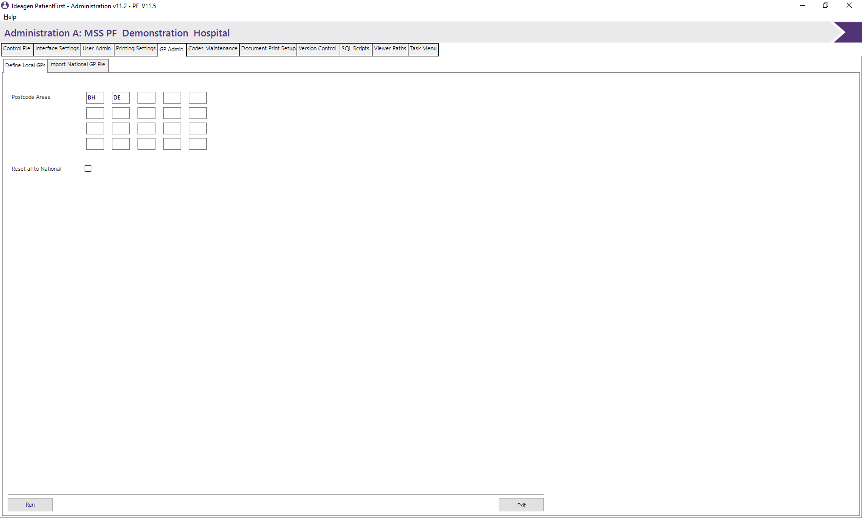
From this screen, you can specify which GP’s are considered local to the hospital site.

Postcode Areas
Enter the district portion of the postcodes in each of the boxes (e.g for BH14 0LS enter BH14). You can specify up to 20 local areas. Once this is set, every GP in the national GP file with a postcode falling under one of these values is considered to be a local GP. When done, click the Run button at the bottom of the screen.
Note that the current postcode areas are now saved in this program so it is normal for the values to remain after clicking the run button.

Reset all to National
Because the GP’s are set to local status in the GP master file, it is advisable to reset all the GP’s to national before changing the local areas. This ensures that no GP’s are left as local by accident. Tick this box and click run to make the changes. Then re-enter the new postcode areas as above.

Import National GP File
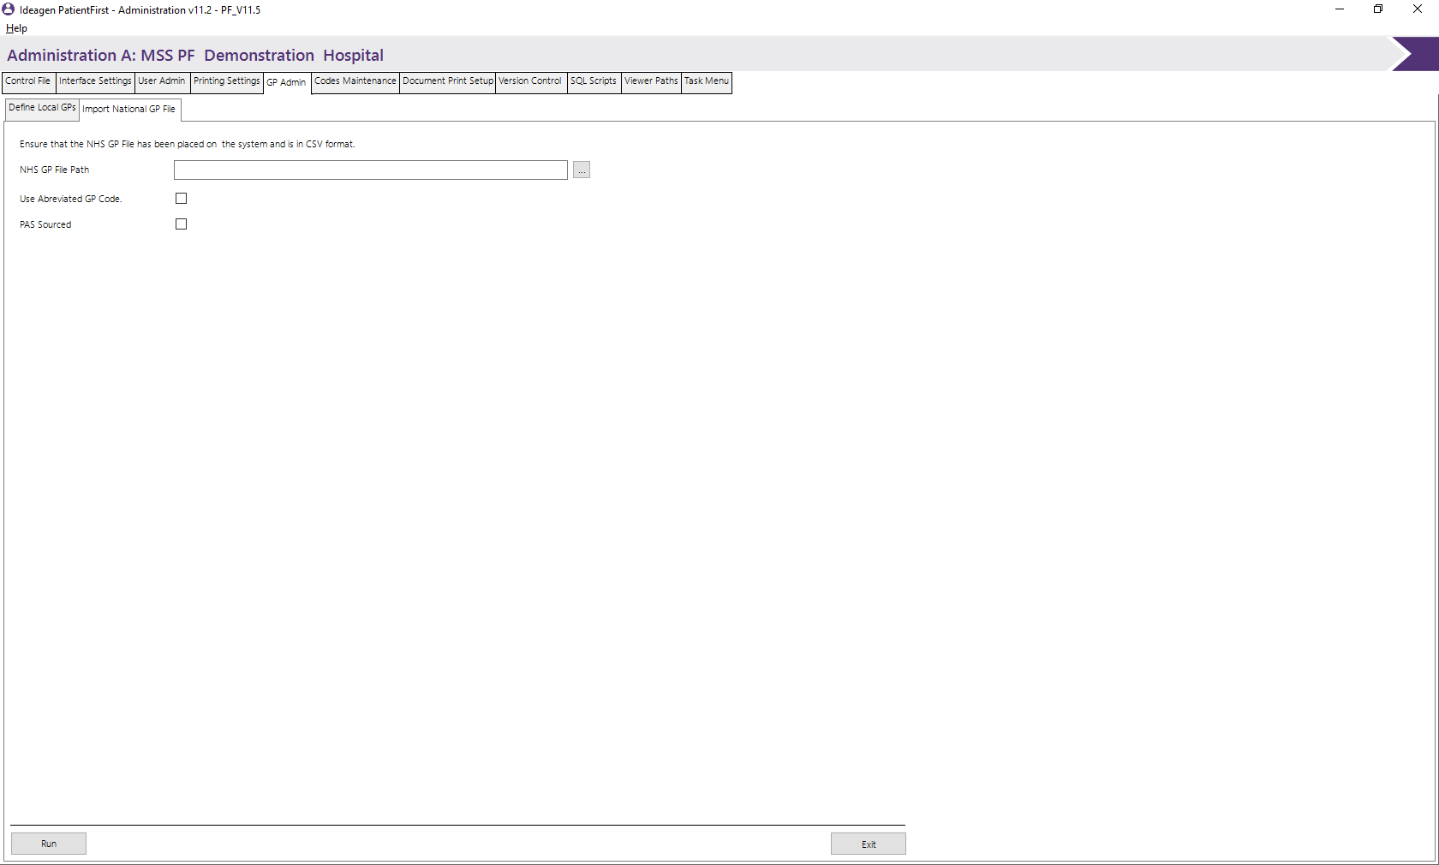
This screen allows you to import a new/updated GP file from the NHS. The new imported file will update the GP master file with new and changed records. No records are deleted; instead old records are simply flagged as discontinued/old.

NHS GP File Path
Enter the path of the new file to be imported. The button can be used to search for the file.

Use Abbreviated GP Code
This function strips the first and last characters from the national GP code if your current hospital PAS still uses the old shortened code.

GP Maintenance
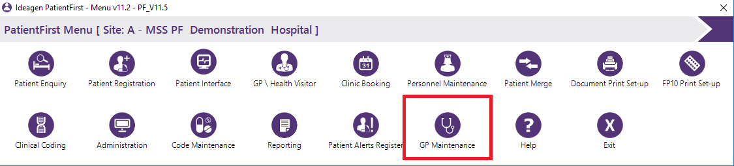
This screen allows the editing of individual GP records and can be accessed from the PF Menu.

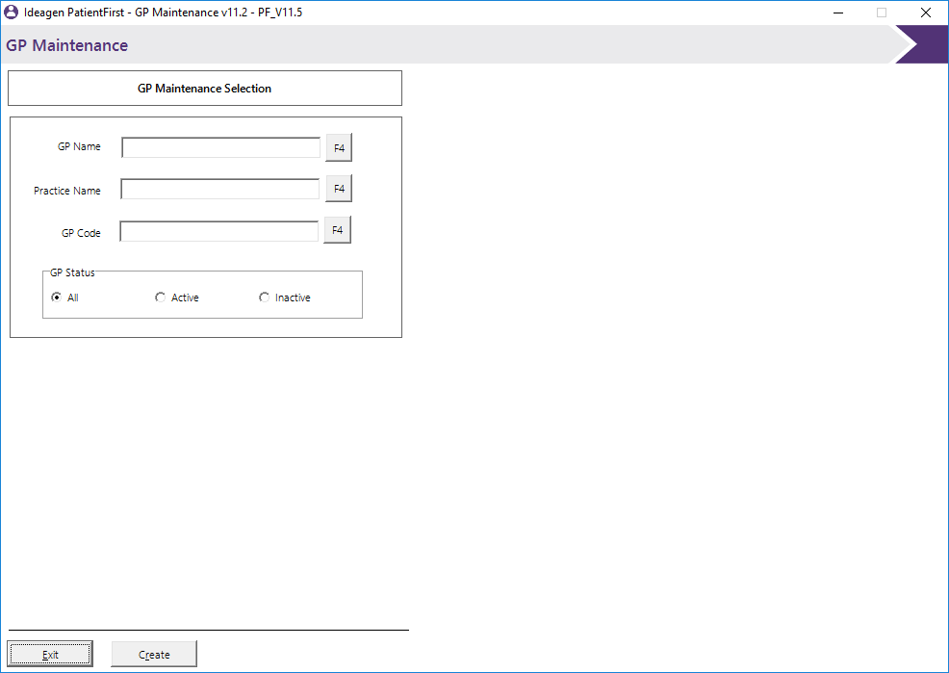

You can search here using the GP’s name or the practice name as well as the GP’s code and also refine the search to include or exclude inactive GPs. Pressing the F4 buttons will give a list of matching local GP’s however if you are looking for a GP that is not in the local area you will need to switch to national using the radio buttons in the bottom right hand corner of the GP look up screen.
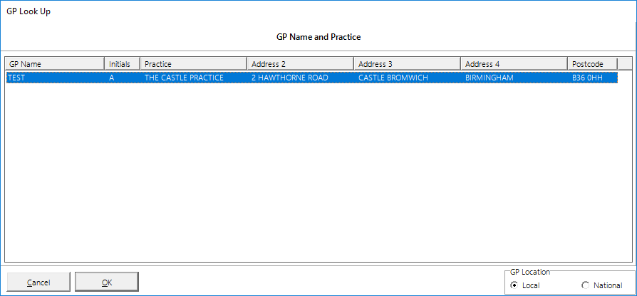

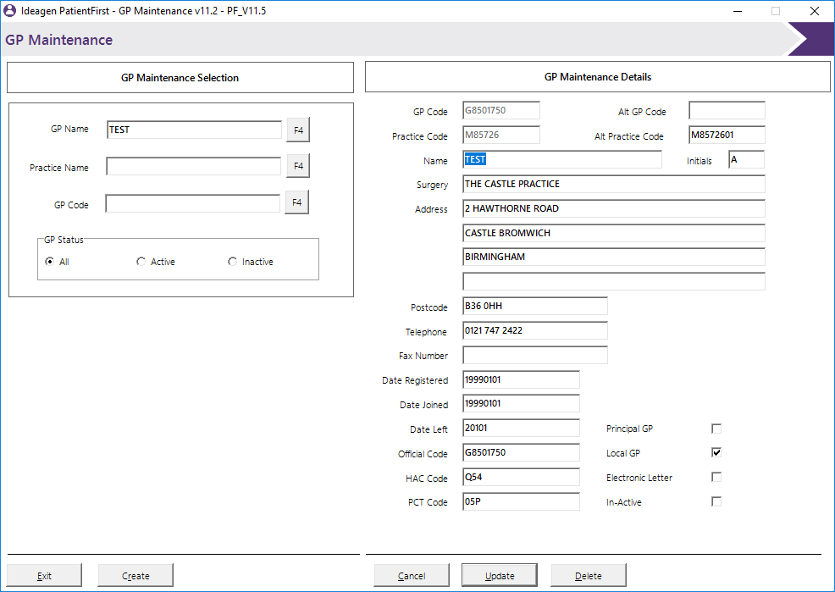
Once you have found the GP you can edit the record by double clicking the record from the list to bring back the GP details screen which you will be able to edit.

You can edit any of the information within here except from the GP and practice codes. Once you have finished editing press the update button to confirm your changes otherwise the changes will not be saved against the GP master file.
Records can also be deleted from here although this is not recommended as it will affect patients that already have this GP listed on their records. Instead of deleting the record it is advisable to check the in-active status box. If you must delete a record, simply press the delete button.

Document Print Setup
The Document Print Setup tab will automatically launch the Document Setup program to allow you to edit the document layouts and field entries. Detailed use of this function is detailed in a separate document (PF_Document_Setup)
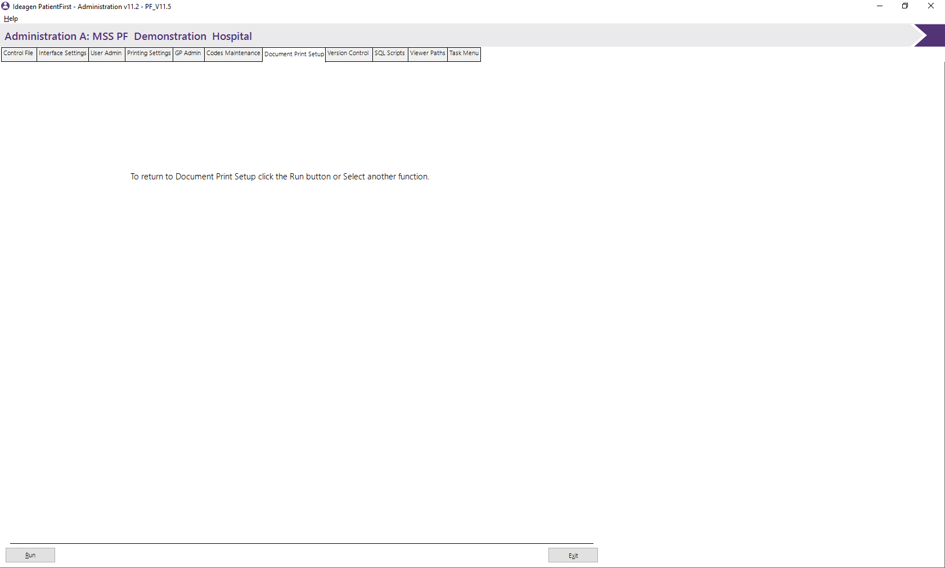
If the application does not automatically run can click the run button on the bottom of the screen or from the PF Menu.

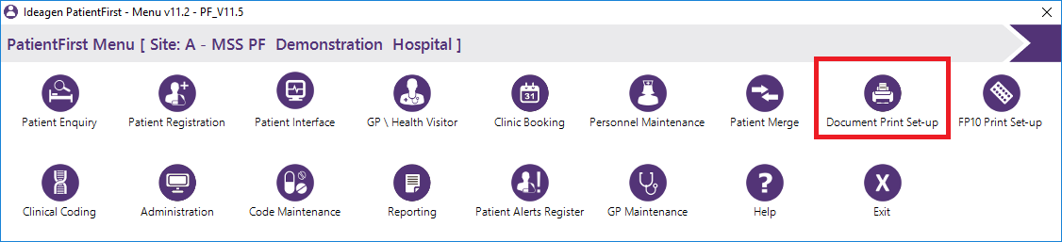

Version Control
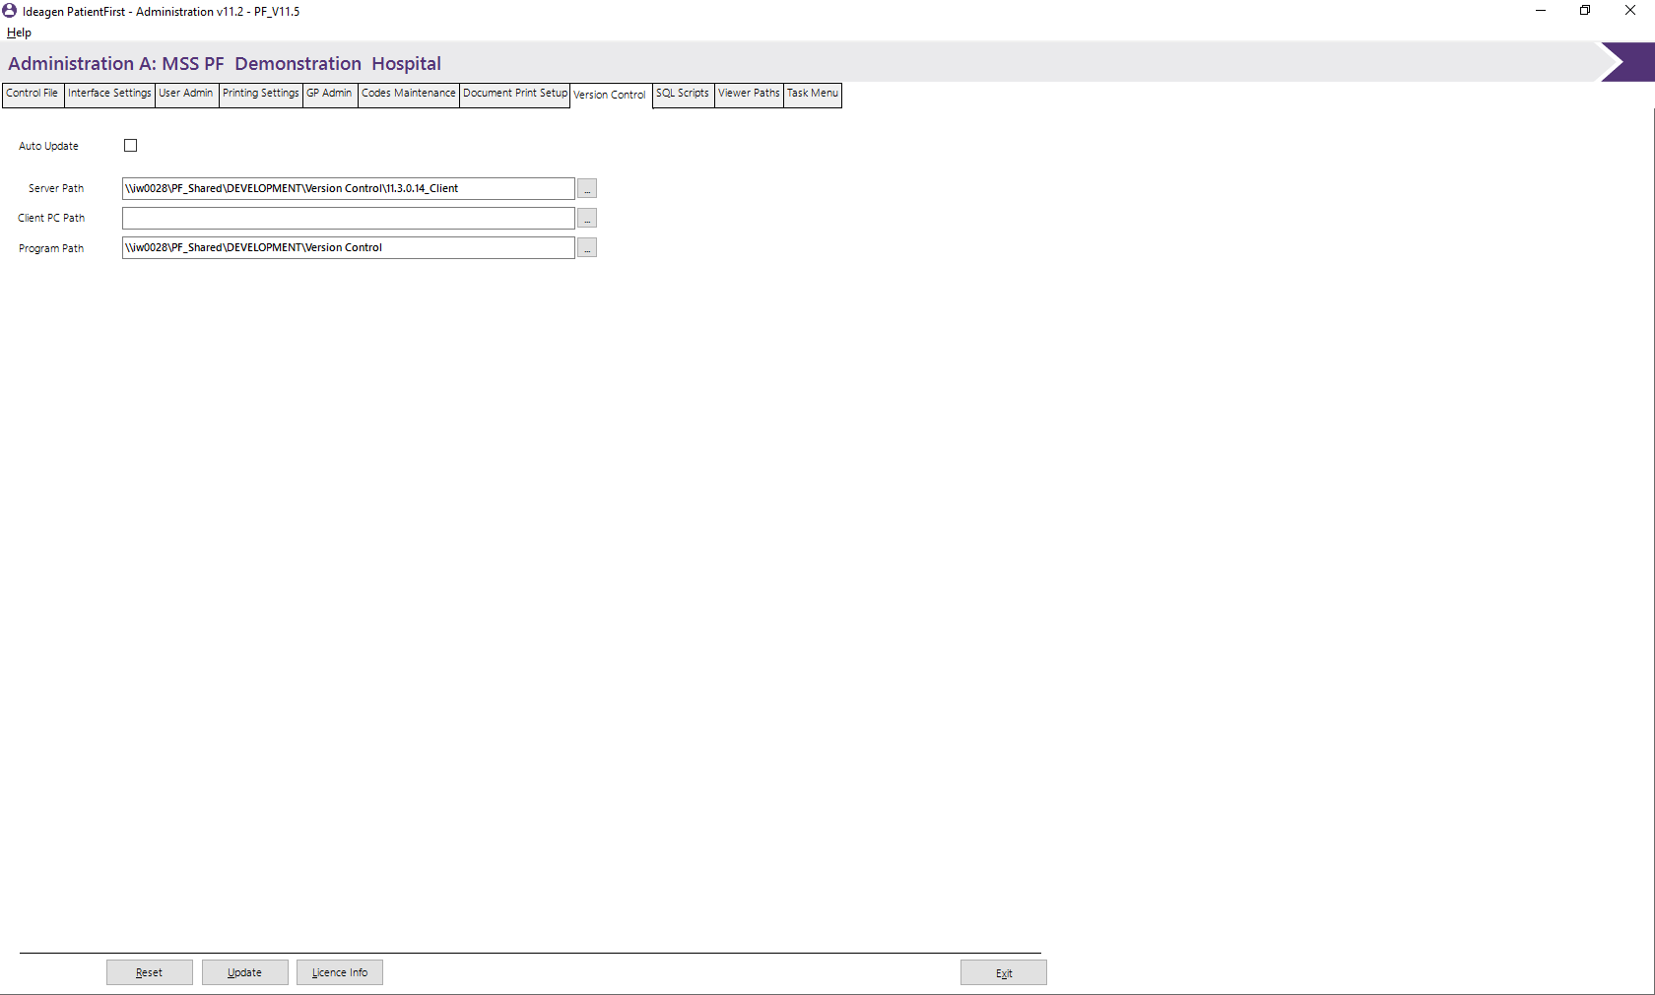
This screen controls the auto update function that allows the system to automatically update itself from the server and is site specific.

Auto Update
This enables/disables the auto update function. When checked, the program will periodically check the server for updated program files and download them to the client machines ensuring all machines are up to date all the time.

Server Path
In this field, you must enter the path of the server and the folder where the new program files will be stored. Simply place any new programs in this directory on the server and the clients will install them automatically.

Client PC Path
This is the path on the local client machine where the programs will be copied to. This must be the local PatientFirst installation directory (usually C:\PrgoramFiles\MSS\PF).

Program path
This shows the path of the version control program on the server machine. This program performs the automatic updates and is not stored in the same directory as the new programs. This will usually be setup by MSS and should not need to be changed.

SQL Scripts
The SQL scripts window is for testing and implementation purposes and allows the administrator to see what SQL scripts have been run on the database. This screen cannot be edited and is for information purposes only. MSS may periodically require you to view this page to ensure all required scripts have been run and your database is up to date.
